


United Nations Development Programme
Country: Mongolia

PROJECT DOCUMENT

Project Title: | Nationally Appropriate Mitigation Actions in the Construction Sector in Mongolia
UNDAF Outcome(s): | Improved sustainability of natural resources management and resilience of ecosystems and vulnerable populations to the changing climate
UNDP Strategic Plan Environment and Sustainable Development Primary Outcome: | Sustainable access to energy and improved energy efficiency
UNDP Strategic Plan Secondary Outcome: | Planning, policy frameworks and institutional capacities to substantially reinforce action on climate change
Expected CP Outcome(s): | Improved sustainability of natural resources management and resilience of ecosystems and vulnerable populations to the changing climate
Expected CPAP Output (s): | Capacities of vulnerable sectors and communities strengthened in climate change adaptation and mitigation
Executing Entity/ Implementing Partner: | Ministry of Construction and Urban Development, Government of Mongolia
Implementing Entity/ Responsible Partners: | Ministry of Environment; Green Development and Tourism; Ministry of Energy; and UNDP

Brief Description
The objective of the project is to facilitate market transformation for energy efficiency in the construction sector through the development and implementation of NAMA in Mongolia. This objective will be achieved by removing barriers to increased adoption of energy efficiency technology in construction sector through three components; i) establishment of baseline energy consumption and GHG emission in the construction sector ii) development and implementation of NAMA in the construction sector iii) measuring, reporting and verification (MRV) system for NAMA. This project will be implemented over a 40 months period and is expected to achieve GHG emission reductions through the displacement of electricity heat generation from coal power plants and CHPs. Direct GHG emission reduction over the lifetime of the project is estimated to be 64,219 tCO_{2e}. The estimated range of potential indirect emission reduction is 57,435 to 438,926 tCO_{2e} that is cumulative for a 10-year period after the end of the project.

Total resources required $8,169,863
Total allocated resources:
- GEF $1,269,863
- Government $3,350,000
- Private sector $3,450,000
- UNDP $100,000
Programme Period: 2017 - 2020

Atlas Award ID: 86244
Atlas Project ID: 93540
PIMS # 5315

Start date: June 2017
End Date: September 2020

Management Arrangements NIM
PAC Meeting Date TBC

Agreed by (Government):
Date/Month/Year

Agreed by (Executing Entity/Implementing Partner):
Date/Month/Year

Agreed by (UNDP):
Date/Month/Year

Table of Contents

ACRONYMS 5
SITUATION ANALYSIS 7
STRATEGY 26
PROJECT RESULTS FRAMEWORK 56
TOTAL BUDGET AND WORKPLAN 59
MANAGEMENT ARRANGEMENTS 64
MONITORING FRAMEWORK AND EVALUATION 68
LEGAL CONTEXT 71
Annex I: Applicable EE Technologies for Demonstration Projects 73
Annex II: Risk Analysis 79
Annex III: Detailed CO₂ Calculations and Assumptions 81
Annex IV: Co-Financing Letters 84
Annex V: Terms of Reference for Project Staff and Consultants 85

ACRONYMS
APR  ATLAS | Annual Project Review  UN Budgeting and financial reporting program
AWP  BCNS  BEEC  BEEP  BTOR  CDC  CH₄  CHP | Annual Work Plan  Building Codes Norms and Standards  Building Energy Efficiency Center (of MUST)  Building Energy Efficiency Project (prior UNDP GEF project that was Implemented in Mongolia from 2009 to 2013)  Back To Office Report  Construction Development Center (of MCUD)  Methane  Combined Heat and Power (power plants)
CO  COP  C0₂-eq. | Country Office  Conference of the Parties (of UNFCCC)  Carbon Dioxide Equivalent
CP | Country Programme
CPAP  DSM  EA  EE  EEG | Country Programme Action Plan  Demand Side Management  Executing Agency  Energy Efficiency  Energy and Environment Group (of UNDP)
EOI | Expression of Interest
EOP  ERC  ERC | End of Project  Evaluation Office Evaluation Resource Center (of UNDP)  Energy Regulatory Committee (of Mongolia)
FSP  Gcal  GDP | Full Scale Proposal  Gigacalorie (4.184 Gigajoules or 1,162.2 kWh)  Gross Domestic Product
GEF | Global Environment Facility
GHG  GNI | Green House Gas  Gross National Income
GOM  IA  ILB  HOB  K | Government of Mongolia  Heat Only Boilers  Incandescent Light Bulbs  Implementing Agency  Kelvin (zero K is absolute zero or -273.15C, a Kelvin has the same magnitude as a degree Celsius
KWth  LEDS  LUCF  MARCC | Kilo Watt Thermal  Low Emission Development Strategies  Land Use Change and Forestry  Mongolia Assessment Report on Climate Change
M&E  MCUD  MDG  MoE  MEGDT  MNET  MNT  MTR | Monitoring and Evaluation  Ministry of Construction and Urban Development (formerly MRTCUD – Ministry of Roads, Transport, Construction and Urban Development)  Millennium Development Goals  Ministry of Energy  Ministry of Environment and Green Development (and Tourism)  Ministry of Nature, Environment and Tourism (restructured into MEGD from December 2014)  Mongolian Tugrik or Tögrög  Mid Term Review
Mt | Million Tonnes
MTE | Mid-Term Evaluation
Mtoe  MUST | Million ton of oil equivalent  Mongolian University of Science and Technology
MW  NAMA  NGOs  MRV | Megawatt  Nationally Appropriate Mitigation Action (as introduced at UNFCCC COP 17 meeting in Durban)  Non Government Organisations  Measuring Reporting and Verification
NPC | National Project Coordinator
NPD  OECD | National Project Director  Organisation of Economic Cooperation and Development
PAC | Project Advisory Committee
PIF  PIMS | Project Identification Form  Project Information Management System (of UNDP)
PIR  PMC | Project Implementation Reports  Project Management Cost
PMU | Project Management Unit
PPG  PPP | Project Preparatory Grant  Purchasing Power Parity
PPR | Project Progress Reports
PSC  QPR  RCU  RE | Project Steering Committee  Quarterly Progress Report  Regional Coordination Unit (of UNDP, for Mongolia the relevant Asia-Pacific RCU is based in Bangkok)  Renewable Energy
RTA  SBAA  SNC  TE | Regional Technical Advisor (of the UNDP Asia-Pacific Region)  Standard Basic Assistance Agreement (for UN operations in a particular country)  Second National Communication (to the UNFCCC)  Terminal Evaluation
tCO_{2e}  TOR | Ton of carbon dioxide equivalent  Terms Of Reference
UAC | Unit Abatement Cost
UNDAF | United Nations Development Action Framework
UNDP  UNEP | United Nations Development Programme  UN Environment Programme
UNFCCC | UN Framework Convention on Climate Change
USD or US$  VAT | US Dollar  Value Added Tax

SITUATION ANALYSIS

Context and Global Significance
Country background
- After the economic reforms during the late 1990’s, Mongolia has been one of the fastest growing economies in the past decade, riding on the back of large stock of resources and immense Foreign Direct Investment (FDI) inflows to the mining sector. Real Gross Domestic Product (GDP) growth averaged 9% over the past decade, and per capita income had more than quadrupled, to over $4,000. Mining accounts directly for 20% of the economy, while the total share, including indirect impacts, is likely much higher— mineral exports account for over 40% of GDP. The economic reforms have also stimulated rapid growth in the construction sector as well as in the energy consumption pattern. Throughout the capital city, large building construction projects and high-rise commercial and residential buildings have become a widespread and common scene. However, recently economic growth slowed from 7.8% in 2014 to 2.3% in 2015 amid declining exports from a continued weakening of the commodity market and slower growth in the key export market of China. Growth forecast for 2016 is lowered at 3% reflecting a deteriorating external environment, drought-affected harvests, necessarily tight monetary and fiscal policies, and, on the positive side, the start of underground works at Oyu Tolgoi in mid-2016.

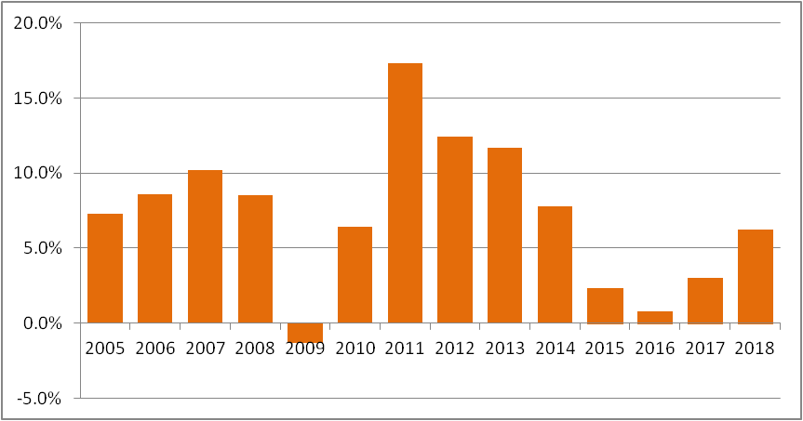
Figure 1: Mongolia economic growth rate (The World Bank, 2016)

- Around 64% of the Mongolian population lives in Ulaanbaatar (UB), Erdenet and Dakhan cities. UB alone accounts for almost 45% of the country’s population. According to the National Statistical Office of Mongolia, the population in 2015 was 2.972 million, and this is forecast to increase to 3.642 million in 2035. Table 1 below shows trends of the national population growth rate and the UB growth rate. It is estimated that the UB proportion of the national population will increase from 44.6% in 2015 to 59.4% in 2035, mainly due to migration of rural population to the city. As more and more people move to urban areas in search of economic opportunities, the number of buildings needed to house them and energy consumption in the building sector will continue to rise.

Table 1: Population Projection
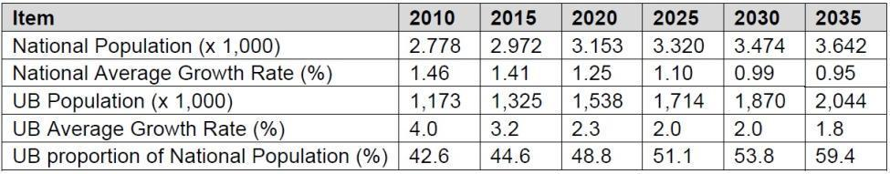
Source: NSO Population Projection 2008-2030

Construction Sector
- The current housing options in Mongolia range from Gers (or felt tents), small affordable apartments to ultra luxury houses, apartments and penthouses. Rural migrants generally settle in Ger area around UB city. Crowded Gers without access to heat grid and sewage system intensify environmental problems in UB with smoke from coal stoves for Ger space and water heating. The Government of Mongolia (GOM) has been trying to relocate these Ger residences to apartments with proper infrastructure in the City by providing low interest loan (8%) and other housing programs i.e. 100,000 housing program. With low income population move from Ger to mid-rise apartment and high income population move to high rise apartment and detached houses, the trend of housing in Ulaanbaatar is projected to shift towards mid-rise apartments and detached houses while Gers foreseen to be diminished. Mid-rise apartments will constitute a large share of the housing in the future. The housing unit projection is shown in Figure 2.

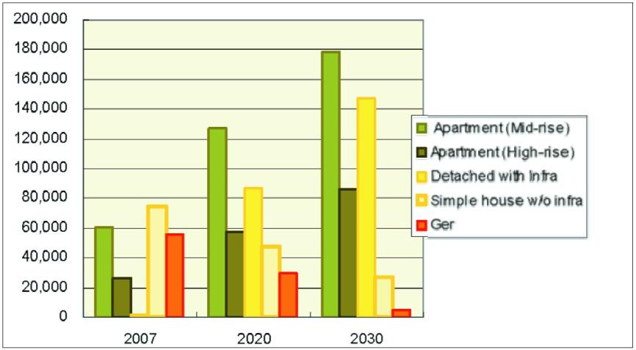
Figure 2: Housing Projection units by types
(Source: Thermo-Technical Rehabilitation of Pre-cast Building in Ulaanbaatar, GITEC, 2011)

- In the Mongolian context, the “construction sector” refers to heavyweight, multi-storey commercial, residential apartment buildings and private houses (within or outside housing estates) since these are connected to water supply, sewage, district heating and domestic hot water systems. The construction sector buildings are concentrated in major cities, particularly in UB, Erdenet and Darkhan. Ulaanbaatar’s building stock comprises pre-cast concrete panel buildings from the 1970s, 80s and early 90s. A total of 514, five to twelve stories pre-cast panel buildings accommodate some 47,000 apartments. There is no comprehensive database for building floor areas for these pre-cast buildings and those built after the 90s where other construction practices have been adopted. However, it was estimated that there are approximately 36 million square meters of residential apartments and 14 million cubic meters in public/commercial sector buildings, as shown in Table 2.
Table 2: Building area in district heating networks in major cities (2012)
Cities | Customers | Residential Apartments (sq. meters, m²) | Public / Commercial Buildings (cubic meters, m³)
Ulaanbaatar | 287,200 | 30,980,228 | 6,562,480
Erdenet | 102,781 | 1,719,107 | 3,209,000
Darkhan | 90,808 | 1,271,309 | 3,649,827
Choilbalsan | 40,399 | 596,786 | 1,114,100
Dalanzadgad | 2,624 | 20,992 | 88,165
Baganuur* | 29,254 | 678,418 | N/A
Nailakh* | 34,734 | 815,960 | N/A
Bagakhangai* | 4,202 | 75,040 | N/A
Total | 592,002 | 36,157,840 | 14,623,572
Note: *Baganuur, Nailakh, and Bagakhangi are in the nine Districts of Ulaanbaatar.
Source: Final Report Heat Forecasts, Updating Energy Sector Development Plan, ADB, 2013
- Although the comprehensive database for building floor areas in Mongolia is not available, the total building floor area of pre-cast and non-pre-cast panel buildings was computed, whereby the total floor area in construction sector in 2013 is estimated at 41,573,977 m². This is a sum of the total floor areas of 36,157,840 m² in residential apartments and the total floor areas of 5,416,137 m² of public/commercial buildings estimated from a volume of 14,623,572 m³ in the public and commercial sector.
Table 3: New Construction by Building Type, 2006 - 2013
Year | 2006 | 2007 | 2008 | 2009 | 2010 | 2011 | 2012 | 2013
Residential - number of apartments | 4,579 | 3,725 | 5,416 | 6,338 | 9,899 | 11,349 | 11,413 | 18,012
Hospitals - number of beds | 384 | 320 | 246 | 221 | 305 | 424 | 613 | 228
School and cultural Institutions - number of seats | 8,641 | 11,641 | 7,894 | 9,965 | 17,593 | 16,539 | 19,628 | 20,012
Source: National Statistics Office
- With an increase in housing demand from economic growth and a surging rural to urban migration, the construction sector had been thriving reciprocally over the past decade. However, the current financial situation of Mongolia with reduced foreign investment (especially for the mining sector) alongside the government focusing on reducing its significant budget deficit levels, new construction activity is expected to slow down in the next 3-4 years (2015 to 2017-18) from its boom year levels of 2010-2013- back towards more sustainable growth levels more like that of 2008-09 and 2014. This is going to be complemented by a slower, yet more sustainable GDP growth along with a reduction in the consumer price inflation rate which is expected to meet the central bank’s policy target of 7% by the end of 2016. Consequently, consumer mortgage and developer interest rates are likely to be reduced, thus, maintaining a gradual activity level in the construction sector. The projection of housing demand based on the population growth rate indicates approx. 140,000 apartment units will be constructed between 2020 and 2030, which translates to around 14,000 new units annually.

- As the building stock continues to grow, energy demand simultaneously escalates. It is projected to rise at an average rate of over 10% from 2015 to 2035, reaching almost 130 PJ by 2035. During the long-lasting winter season in Mongolia, heating of homes, apartments and offices is an absolutely necessary condition as air temperatures drop to as low as -40°C. The heating season lasts for 8 months which exerts additional constraints on energy demand. This poses a challenge to both the local and global environment since coal remains the major fuel used to meet the demands.

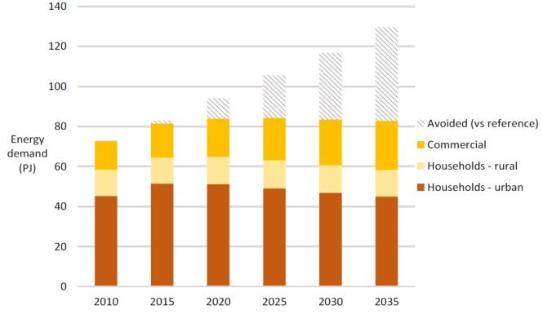
Figure 3: Energy demand in the buildings sector in the “expanded green energy” scenario

- Nearly about 96% of electrical and heat energy generation is based primarily on coal. The single biggest coal consumers are the Combined Heat and Power Plants (CHPs) and Heat Only Boilers (HOBs). Electricity and heat production increased by 6.75% and 4.3% respectively from 2013. In 2014, the country used 6897.4 million kWh of electricity, of which 76.5% came from Combined Heat and Power plants, 2.8% from renewable energy resources, 0.6% from diesel generators and 20.15% from imports out of which 389.98 million kWh was from Russia and 999.26 million kWh from China. All buildings in urban and Aimag (Provincial) centers have a grid electricity supply available, and nearly all (except the most remote) Soum (local administrative centers) now have a grid electricity supply. In built-up outer urban areas and in most Aimag centres, Heat Only Boilers (HOBs) are used with local district-heating networks to distribute heat to buildings. In areas not connected to the district heating networks, such as the sprawling “Ger” areas, private homes in rural and semi-urban areas, individual ger stoves, wall stoves, and hot water boilers burning coal (with significant undocumented and not completely sustainable use of fuel wood) is used for energy needs.

- Typically, thermal energy is used for the heating of buildings; the production of goods and services; and the provision of hot water for households. Electricity is used for lighting, motors, thermal electric equipment (mostly for cooking), electric appliances and equipment, and is increasingly being used for space heating. The efficiency of energy use in the residential and service sectors is generally low. The priority goal of any energy efficiency interventions in the residential and commercial subsectors is therefore to promote more efficient use of energy and the substitution of low cost and low quality raw coal with relatively cleaner energy sources.

- The energy sector is by far the largest contributor with almost 64% of total GHG emissions in 2010. At current rates, Mongolia’s GHG emissions is expected to increase four times the 2006 levels by 2030 and account for approx. 82% of the total to 51.2 Mt CO2-eq. So far, commercial and residential sectors together contribute to over 11% of the overall CO₂ emissions which is higher than that from the transport, industrial and agricultural sectors. Despite that, there is dearth of data on energy consumption and GHG emission from end-use sub-sectors such as the construction and building sectors.

- Although the overall GHG emissions are comparatively low, per capita emissions are relatively high compared to other developing countries - due to Mongolia’s extremely cold continental climate, the widespread use of fossil fuels for energy, and the low efficiency of fuel and energy use. Mongolia’s GHG mitigation policy is primarily directed towards burning coal by more environmentally friendly technologies, as well as focusing on the efficient use of the electricity and heat produced from coal burning, in particular through the use of energy efficient appliances and equipment and by reducing heat losses in buildings. In addition, the use of renewable energy sources for electricity and for heat supply is also a relevant GHG reduction strategy for the country. Estimates suggest that with an appropriate mix of policy and financial instruments Mongolia can keep the energy demand in the construction sector relatively constant at 80 PJ (22,222 GWh) until 2035 with avoided energy of more than 40 PJ (11,111 GWh) in 2015. Moreover, the Government aims to reduce 20% of heat loss from buildings by 2020 and 40% by 2030 compared to 2014 levels. These targets have been well reflected in the INDC submitted by Mongolia to the UNFCCC. A marked lack of financing has been identified as one of the pronounced challenges in translating these pledges into concrete action.

- In this context, the Government of Mongolia recognizes Nationally Appropriate Mitigation Actions (NAMA) as a comprehensive instrument to translate the short and medium term targets into action by outlining the means and action to implement them. NAMA has been seen as a novel voluntary framework that can help the Government catalyze national and international support and finance to achieve effective and transformational GHG reductions from the construction sector while simultaneously achieving sustainable development targets.

Barrier Analysis

- The past few years have seen encouraging progress in improving the energy utilization rate of new buildings through the implementation of the Building energy Codes, Norms and Standards (BCNS). Significant advances were made towards this through the contribution of the previous UNDP-GEF Buildings Energy Efficiency Project (BEEP). The project was successful in updating and implementing the revised EE BCNS; developing technical and institutional capacity in adopting the energy code; engaging with financial institutions, local associations of construction sector manufacturers, suppliers and engineers; creating awareness and outreach on the benefits of energy efficiency measures and stimulating action by showcasing practical demonstrations largely supported by private sector participation. Despite BEEP’s contribution in laying a solid foundation on the buildings energy efficiency agenda and catalyzing the market to a certain extent, challenges persist which are particularly noticeable when it comes to attract financing for scaled investments in EE measures, achieving 100% compliance, and to go beyond code.

- Moreover, in Mongolia energy is still significantly subsidized and underpriced. According to the Energy Law, tariffs should be fully cost covering. In practice, however, the tariffs are kept at much lower levels (around only 25% of the full real cost) and does not reflect the actual economic costs. This is more pronounced for heat and electricity supplied by district heating networks. Heat tariff is not based on consumption based billing, rather, charged by area or volume of the apartment or houses. In addition, the government subsidizes the cost of coal at the power plant to keep the heating tariff low. This does not provide sufficient financial motivation for building industry, entrepreneurs, operators and property to invest in energy efficient measures. It was recommended that the large subsidies currently provided to energy sector companies should be replaced by channelling any remaining financial support directly to vulnerable consumer groups to mitigate the impacts of tariff increases. However, the politics of implementing these electricity and heat tariff reform recommendations remains highly problematic. Although policy makers and all parties in the energy sector are well aware of this issue, restructuring of energy tariff requires commitments from high-level policy makers, and the process could be several years to realize the results.

- What’s more, there seems to be a regulatory disjuncture in the construction sector as reflected by the escalating number of newly built curtain-wall buildings. Such buildings inevitably suffer from extremely high winter heat loss and high summer heat gains, thereby, require supplemental heating and cooling; and, are highly energy inefficient. Owing to these characteristics, curtain wall buildings are intrinsically completely thermally inappropriate in Mongolia’s extreme winter climate. However, they continue receiving construction permits and are being built because: they are thought to reflect an international “modern” architectural style; construction methods maximise the gross rentable floor area for a given building plan area; have a lower initial capital cost; and employ lightweight building structural systems that can be constructed in a shorter time period during Mongolia’s short 5-month summer “construction season”.

- Barriers that restrict widespread adoption and investments in energy efficiency in the construction sector occur across a range of areas that need to be strategically addressed to facilitate marked progress. Key barriers include those related to: systematic and institutional coordination, financial, market, technical and informational barriers. Each of these have been discussed below in Table 4.
Table 4: Summary of Barriers on the Implementation of Energy Efficient (EE) Technologies and Applications in the Construction Sector in Mongolia
Systematic and Institutional Coordination Barriers
Insufficient EE policy implementation and coordination mechanisms: It should be noted that, in 2015 the State Policy on Energy (2015-2020) was approved by the government of Mongolia wherein EE was one of the three major policy principles. The Energy Conservation (EC) Law was subsequently approved by the Parliament in November 2015. However, implementing rules and regulations are still nascent and a centralized agency responsible for monitoring compliance and coordinating actions on energy conservation and energy efficiency is missing.

The UNDP-GEF supported BEEP project was successful in updating the Building EE Code/Norms/Standards (BCNS) system to make it more appropriate for Mongolian conditions. Consequently, an increasing number of new buildings have been following the updated BCNS EE system and higher levels of energy utilization in new constructions have been reported. One of the lessons learned through BEEP is that strict implementation, enforcement and monitoring compliance of the updated BCNS requires substantial resources, time and effort, hence, leaving significant room for improvement. Monitoring the compliance of energy codes and evaluation of their impact has not been sufficiently addressed in the policy design, and as a result, it has been challenging to estimate accurately the compliance level and effectiveness of the updated energy codes.

With respect to institutional issues, the State Inspection Agency and the Construction Development Center (CDC) still lack necessary capacity and financial resources to inspect and monitor actual construction results, standards applied and ensure full compliance with all BCNS EE requirements, in particular in the large commercial buildings segment.
Lack of systematic approach, comprehensive tools and capacity to inform EE policy measures: Comprehensive database on building stock is still rudimentary and disperses among different agencies and organizations involved in the building sector at central and provincial levels. Where available, the data is categorized in different units to serve respective agencies’ purposes, e.g. floor area in m2, or more predominantly in number of occupied rooms for hotels and hospitals. A single database providing nationwide building stock data has not yet been developed.

Likewise, there has been no systematic approach in consolidating, maintaining and regularly verifying detailed data on historical and current energy consumption in the end use sectors, including the construction sector. Agencies such as District Heating Company, Ministry of Energy and Ministry of Environment, Green Development and Tourism are separately engaged in compiling energy consumption data but there is no collaborative approach to compile, analyze and share the data to fulfill various purposes such as establishing reference baselines, benchmarking and for comparisons. As a consequence, there is a lack of systematic understanding of how and where energy is actually used in the complex dimensions of buildings in Mongolia, and where exactly energy efficient interventions should be prioritized and targeted. Evidently, the scarcity of “credible” data and information on energy performance has led to a gaping hole in informing and selecting appropriate policy instruments and actions to promote energy efficiency in the construction sector.
Financial Barriers
Absence of Effective Financing Models for EE Investments: A lack of financial ability to target end-users and limited financial capabilities of construction companies has been restraining the propagation of EE technology. Financing is still expensive and/or difficult to access for developers and owners who are prepared to spend more capital upfront for EE buildings - to be balanced by their lower subsequent building running costs. If developers are not able to recoup the incremental investment in energy efficient properties, or if they take longer to sell such properties, developers will naturally be unwilling to further invest in such business propositions. Due to the financial slump in the market, it was noticed that large-scale developers and construction sector fraternity (e.g. manufacturers, suppliers) have gradually refrained from investing further on energy efficient practices and applications.

Suitable and effective financial mechanisms and fiscal products (e.g. off-balance sheet financing, tax incentives) to support EE buildings designs and investments are hardly available. The Clean Air Fund which was earlier providing support has ceased its operation in Mongolia leaving fewer options to financially support the energy efficient construction. In general, commercial banks have stringent requirements for mortgage; a loan term is very short (typically less than 5 years) and the interest rate is very high. Xac Bank which has been the forerunner in providing mortgage loan in energy efficiency schemes also has a strict loan policy. The present interest rate is a whopping 19.2% and requirement on collateral is stringent. The high cost of capital as a result of the lofty interest rates and concomitant risk perception by financial institutions have been consistently identified as one of the key financial barriers to implement energy efficiency in the residential and commercial sectors. The recent economic downturn has affected the financial sector with a higher rate of non-performing loans during the past year. The government 8% interest housing program does not necessarily support energy efficiency housing market as it is not a requirement for the loan program.
Eco and Normal Housing Loan Conditions of XacBank
No. | Condition | Unit | ECO loan | Normal loan
1 | Limit of loan | Million MNT | Not described | 50
2 | Down payment | % | 25% | 30%
4 | Duration | Months | 240 | 120
5 | Interest rate | % Per year | 19.08 | 19.08 - 21.72

Market Barriers
Unattractive economic benefits of EE investments for end-users due to subsidized heat and electricity tariffs: Subsidized energy tariff remains a persistent barrier which provide significant disincentive to property developers and owners to look for more energy efficient solutions, as EE in buildings inevitably involves higher upfront capital costs that must be balanced by lower operational energy costs. Heat tariff is a cross-subsidy of electricity and coal prices are subsidized for power plants to keep the heat tariff low. The current heat tariff for apartments is set at around 0.2 USD/m2 (400 MNT/m2) which for residential buildings is charged by area of the apartment and not by the actual usage. Consumers, therefore, have low interest in energy savings which lead to low demand in energy efficient homes.

In 2014, the energy sector incurred around USD 37m (68.7 billion MNT) of financial losses just at the generation level. The energy cost of grid systems would further increase the real production cost, and increase the real total financial losses.

Production price and sale price of energy in the Central Grid system in Mongolia
Type of energy | Unit | Production cost | Customer price
Electric energy | MNT/kWh | 144 | 122
Thermal energy | MNT/Gcal | 24,000 | 12,000
Source: MoE, 2015

Limited availability of high performing, advanced EE building materials: Commercial availability of high quality, advanced energy efficient materials/systems is mostly through imports but they too are limited. This is more evident with regards to the advanced triple/quadruple glazed, low-e, argon filled and insulated frame windows that are actually needed in Mongolia’s extreme winter climate for BCNS EE code compliance for highly glazed/curtain wall buildings, or in buildings that will significantly (e.g. 20-50%) exceed BCNS minimum EE levels. There are some local manufacturers who are capable of producing some of these advanced insulation materials, including argon filled double/triple glaze window, but the market demand is still low that manufacturing cannot reach the economy of scale, putting the cost of these materials at considerable prices.

Information and Awareness Barriers
Lack of credible information on EE construction materials, equipment and cost effective state of art technologies: Although the BEEP has been very instrumental in generating widespread awareness on EE, there is still a compelling need to propagate more information, for instance, centralized database of EE construction materials and equipment; index of professional services and suppliers; financing information/opportunities; information offices with professional experts to guide and support building owners or developers. To date there has been inadequate effort in consolidating and verifying such information. Moreover, real life demonstration on cost effective, best available technologies and practices to fully comply with and further go beyond codes are also limited. One pertinent example would be the demonstration of improved energy efficient curtain wall building approach which has not yet been demonstrated in Mongolia. This is highly relevant in the current context when curtain wall buildings have been rampantly booming. They require advanced EE measures to be thermally appropriate to Mongolia’s extreme climate. Use of triple (or ideally quadruple – 4 pane) glass with low-e and argon or krypton gas fill and insulated glazing framing elements and insulation of any non-transparent glazing façade elements are some examples which must be demonstrated urgently.

Lack of Tools and Guidelines for Monitoring and Evaluation: Local building practitioners and construction sector professionals do not have sufficient tools, guidelines to help them understand the significance of monitoring and evaluating energy savings accrued from EE measures and how it can inform decision making. Implementation experience in many countries have shown that development of tools and guidelines that assist regulators and designers in conducting technical assessments, monitoring and evaluations will greatly improve the effectiveness of implementing EE measures. Standard guidelines and methodologies for monitoring, reporting and verifying (MRV) specific energy consumption are completely absent. This presents the need of having a reliable MRV framework in Mongolia that will ultimately assist in strategic decision making and action planning.

Stakeholder Analysis

- During project preparation, stakeholder analysis was undertaken in order to identify key stakeholders, assess their interests in the project and define their roles and responsibilities in project implementation. The two primary government agencies with mandates to promote EE in the building sector and NAMA formulation and implementation in Mongolia are Ministry of Construction and Urban Development (MCUD) and Ministry of Environment, Green Development and Tourism (MEGDT). In addition to the two primary agencies, the project will involve other concerned stakeholders as discussed in Table 5 below.

Table 5: Key Stakeholders and their Roles
Stakeholders | Roles
Ministry of Construction and Urban Development (MCUD) | MCUD will serve as implementing entity for the GEF Project. It will also responsible for the overall management of the project including day-to-day project implementation, communication and coordination with UNDP and key partners, providing staff and administrative support, liaison with local governments, monitoring and project financial management. MCUD will chair the NSC.
Ministry of Environment, Green Development and Tourism (MEGDT) | MEGDT is the leading government body for climate change mitigation activities and has the mandate to promote NAMA development and implementation in Mongolia. It will support in the reference baseline survey and analysis for GHG inventory and MRV related activities. It will also assist in employing and adapting GHG emission methodologies in the Mongolian context; modeling and NAMA related activities. MEDGT will be the co-chair of the NSC.
Ministry of Energy (MOE) | MOE is responsible for energy and energy efficiency policy development and implementation. It will assist in energy related data collection for establishing the baseline energy consumption in the construction sector as well as participate in the institutional arrangement for GHG inventory and MRV related activities. MOE will be a member of the NSC.
State Specialized Inspection Agency (SSIA) | SSIA is a government agency responsible for building inspection for compliance with Buildings Codes/Norms/Standards (BCNS). It will assist in monitoring the compliance with EE BCNS.
Ulaanbaatar City Government (UB City) | The Energy Conservation Law, approved in November 2015, defines the role of UB City under Article 7 to organize implementation of legislation on energy conservation and decisions issued by the authority in charge in conformity with the Law, and develop a policy on energy conservation in their respective territories. In the GEF Project, the UB city will coordinate with the CDC and SSIA on improving the building stock data and enforcement of the EE BCNS within its jurisdiction. The UB city staff will be trained in MRV together with CDC and SSIA.
Housing and Public Utility Authority (HPUA) | HPUA is responsible for the provision of municipal services in UB including heating and electricity. HPUS supervises three public utility service enterprises owned by UB city and 18 Housing Companies. HPUA will support in provision of data on building stock in UB city from its database as well as update of the database. HPUA will also participate in the capacity building to incorporate EE measures in its investment plan for renovation of public utilities.
Training , Research and Investment Construction Procurement Unit (MRICPU) | MRICPU is an independent organization established by the MCUD to advance capacity and know-how in the construction sector. It comprises construction worker training, material testing laboratory, construction procurement unit and housing development fund. MRICUP has been appointed by the GOM to implement the 100,000 housing program. In the Project, MRICPU will provide advice on construction materials, testing standards, inspection and labelling. With its experiences in construction worker training, it will assist in formulation, executing and institutionalizing capacity building activities.
XacBank | XacBank will participate in the Project to support the formulation and implementation of financial strategies and barrier removal activities to increase investment in the construction sector.
Property developers (e.g. Normin Construction, Mongolian Properties) | Building developers will be involved in strengthening EE BCNS compliance during the design and commissioning phase of new construction projects, and co-financing EE technologies and application in demonstration projects. Building developers will also benefit from capacity building, training, workshops and seminars.
Mongolian University of Science and Technology (MUST); Supreme Council of Condominium Associations (SCCA); Mongolian Civil Engineers Association (MACE); Building Material Manufacturer Association. | Academia and civil society will be involved in the development of capacity building for organizations and individuals involved in design, development and implementation of EE buildings. Professional and industry association will play an active role in disseminating information and raising the awareness of different stakeholders on EE in buildings by using their current networks, and participate in development of demonstration projects. For e.g. MUST will co-finance the demo projects in retrofitting its existing building and incorporate energy efficient design in its new laboratory building.

Baseline Analysis

Table 6: Baseline Analysis
Baseline project | Period | Budget  US$ | Brief Baseline Description | Linkage to the GEF project
1. The Thermo-Technical Rehabilitation (TTR) of public and apartment buildings in Ulaanbaatar/ Mongolia, UB City | 2014-2018 | 300,000 | The TTR project promotes heat energy savings through installation of additional insulation of panel buildings. The baseline activities that will be subsumed under this project include capacity building in insulation techniques; and measurements and computation of energy intensity and energy consumption of precast buildings. | Reference baseline of energy consumption and GHG emission in construction sector.
2. Capacity Building Project for NAMAs Climate Change Coordination Office, Ministry of Environment and Green Development | 2012-2019 | 400,000 | Baseline activities include design and execution of capacity development training modules on GHG accounting systems and effective monitoring of data, reporting and verification of the results achieved. The target audience is public sector professionals engaged in energy and energy end use sectors. The subsumed baseline activities also comprise overall training on identifying and prioritizing feasible NAMA options. | Design and execution of trainings for construction sector professionals on (a) assessing prospective EE measures that can be subsequently included in the construction sector NAMA; (b) understanding the importance of MRV as an operational tool to record, account and monitor the implementation of EE actions. Formulate guidance and framework for data collection on energy savings, buildings stock and characteristics, user behavior, etc.  Develop and implement standard methodologies to assess, report and verify GHG and non-GHG outcomes of the NAMA.
3. Eco Loan Program, XacBank | 2012 - ongoing | 50 million | The Eco Loan programme provides loan with discounted interest rates for energy efficient buildings and products. However, the uptake is not adequate. In order to boost the loan portfolio XacBank is implementing complimentary activities such as marketing and outreach programme; on the job training to its staff to enhance knowledge on EE technologies and expedite the loan processing. The Bank is also planning to undertake assessments of new and improved financial products and investigate their viability to cover wider technology options and clientele. | Investigate the potential of expanding the Eco Loan programme to target property developers and buyers investing in EE technology and practices that exceed BCNS EE requirements by 20%.  Examine the feasibility and implementation of a dedicated financial scheme to support Small and Medium Enterprises (SMEs) that produce advanced, high performance building materials and products with “beyond code” EE features.  Develop and support an easy to use checklist for building developers, building owners, building tenants, and loan officers to determine whether buildings are compliant with the 20% beyond BCNS EE provisions level that would qualify for a discounted Eco Loan.  Capacity development and technical due diligence support to financial institutions to expedite the loan process of EE projects; develop a list of pre-approved technologies for property developers.
4. Low Carbon Development Partnership Project, Ministry of Environment and Green Development | 2013 - ongoing | $350,000 | Activities include diffusion of low carbon technologies and applications; feasibility assessments and implementation of mitigation actions under the new market mechanism framework including carbon markets and NAMAs. Since development and execution of scaled up mitigation actions typically engage broad based stakeholders, the project also comprises evaluation of governance models, examining options for institutional set up, defining process of interactions for stakeholders involved and so on. | Formulation of marginal cost curves to evaluate mitigation actions in the construction sector and prioritize the most effective measures for inclusion in the NAMA.  Institutional arrangement designed and agreed for data collection, GHG inventory, MRV and NAMA implementation.
5. Advanced Energy Efficiency Glazing Project, Windows Manufacturer association | 2015 – 2022 | 800,000 | This baseline activity comprises manufacturing and applications of triple glazing in buildings in Mongolia. Triple glazing or advanced EE double-glazing, both with insulated window frames, is effectively required by the EE BCNS requirements for all buildings. For curtain wall buildings, the EE provisions of the BCNS require even higher levels of EE (insulation) in glazing systems, to reflect the higher heat loss of even the best EE glazing compared to conventional insulated walls in new buildings in Mongolia. The activities of this baseline project will be subsumed as baseline activities under component 2 of this GEF project. | The GEF project will help provide the impetus, enhanced financing mechanism support, monitoring and demonstration of the enhanced use of improved EE glazing in Mongolia. This will include the enhanced uptake of conventional triple glazed windows and the introduction of new (to Mongolia, but conventional elsewhere in the world) technologies of double and triple glazed windows with advanced EE features, such as low-e coatings, argon or krypton filling between panes, insulated or low heat loss window frames, and of quadruple (4 panes in one frame/unit, or using twin double glazed windows as is now being used in Russia) glazed advanced EE feature windows for curtain wall buildings.

Baseline Scenario

- The baseline scenario is a continuation of the present business as usual situation, which follows from existing government policy, activities, legislation and institutions/mandates in Mongolia. The business-as-usual (BAU), scenario will most likely be characterized by the following:

- Despite stable growth in the buildings stock, improvements in building energy performance will be slow paced owing to lack of effective compliance with the updated BCNS. The construction sector therefore will continue to comprise partially compliant to non-compliant building stock with new buildings meeting only approximately 80% of the EE BCNS requirements. Systems to monitor and penalize non-compliant new buildings will continue to be absent.
- In all building types, windows are still the highest heat loss building element and all current windows still do not fully comply with the BCNS EE requirements. This is more so especially in large commercial buildings with their generally higher glazing ratios and their poorer quality windows. In commercial buildings with curtain walls, the window glazing frames are generally uninsulated aluminum with a resulting extremely high specific heat loss. Moreover, high ground floor and unheated basement heat loss across all types of buildings continues.
- An increasing number of new construction sector buildings with external curtain wall cladding systems will be built in Ulaanbaatar and other cities. Curtain wall buildings with inadequate insulation levels and simple double-glazing are extremely difficult to heat in winter and increasingly require large, capital expensive and costly to run air conditioning (AC) to counter summer overheating. The baseline situation is that such poorly insulated and difficult/ expensive to heat and cool buildings will continue to be built - as there are no case studies of the benefits of highly insulated alternative curtain wall building approaches (as is in fact specified in the EE provisions of the Mongolian building code).
Box 1: Impacts of Inefficient Curtain Wall Buildings on Electrical and Heat Energy Demand in Mongolia
Inefficient curtain wall buildings are hard or impossible to adequately heat with the limited heat network heat supply capacity available in Ulaanbaatar and other large cities in Mongolia. This necessitates the use of expensive and limited electric supplemental heating. They can also require the use of expensive (both capital cost and running cost) central AC systems to combat their inevitable summer solar over-heating, whereas better insulated, higher mass and lower glazing percentage conventional buildings do not require the use of central AC in Mongolian summer conditions.
- Critical lack of properly monitored, evaluated and documented cases that show the actual impact of EE in construction sector buildings in Mongolia.
- Successful demonstration especially on beyond code buildings and state of art construction materials will remain few, mainly focused on BCNS designs, materials and technologies. A key problem will remain in the baseline situation, which is the lack of sufficiently documented and demonstrated knowledge on how to save energy in construction sector buildings.
- Code compliance of buildings remains the primary focus of the promotion and outreach interventions. Lack of promotions for EE building designs that target “beyond code” requirements for building designs.
- EE interventions in the construction sector remain fragmented with a holistic approach largely missing.
- Energy management efforts in buildings will remain low priority to building owners due to highly subsidized electricity price.
- Information on new, superior and innovative EE technologies, materials and suppliers remains scattered and hard to access. This will continue to hamper the market access and effectiveness.
- Difficulty to access financing for construction sector EE projects continues, due to small project size to justify high transaction costs of the financial institutions, collateral based project financing modalities, lack of innovative financing mechanisms and an appropriate guarantee facility.
- Urban development policies and measures will continue to be focused on moving the urban population from Ger areas and informal private houses to apartments or formal housing estates and not necessarily on improving the energy efficiency of buildings beyond code minimum levels.

- As discussed earlier, the total floor area in construction sector in 2013 is estimated at 41,573,977 m². It is estimated that around 20% (or about 8.3 million m²) of which are precast panel buildings with the energy intensity value of 345 kWh/m². UNDP-GEF BEEP reported an average energy intensity of 200 kWh/m² for buildings before the commencement of BEEP in 2009, while the energy intensity in buildings complying with the new BCNS were measured to be 155 kWh/m². Considering the partially compliance with the new BCNS it is estimated that new buildings would have energy intensity of around 165 kWh/m². Using a conservative approach, the project will reference the average energy intensity of 200 kWh/m² and 165 kWh/m² for building stock before and after 2013.

- Table 7 summarizes key parameters for projection of energy consumption and GHG emission in the business-as-usual scenario.

Table 7: Key Parameters for Projection of Baseline Scenario
Parameters | Value
Total floor area in residential and commercial buildings connected to district heating in 2013 | 41,573,977 m²
Average annual growth rate of building stock | 2.35% ^{(see note)}
Baseline energy intensity of buildings before 2013 | 200 kWh/m²-yr
Baseline energy intensity of buildings after 2013 | 165 kWh/m²-yr
Note: Based on the projected growth referenced by the TTR Feasibility Study Phase 1 Report

- The BAU outcome with respect to GHG emissions in Mongolia construction sector, as shown in Table 8 and Figure 5, is an increase from 4.94 million tones CO_{2eq} in 2015 to approximately 5.45 million tones CO_{2eq} in 2020 and 6.66 million tones CO_{2eq} in 2030. This is based on growth of energy consumption in construction sector to meet the expected demands from 9,526 GWh in 2020 and 11,636 GWh in 2030. This growth forecast use a constant combined grid emission factor as it is expected that Mongolia will still rely mostly on coal.

Table 8: Annual Energy Consumption and GHG Emission by the Construction Sector
 | 2015 | 2020 | 2030
Energy consumption by the construction sector (GWh/yr) | 8,641 | 9,526 | 11,636
Baseline GHG emission (million tCO₂eq) | 4.94 | 5.45 | 6.66
Note: Estimation using the key parameters in Table 7 and the combined EF for electricity and heat energy at 0.52 tCO_{2e}/MWh

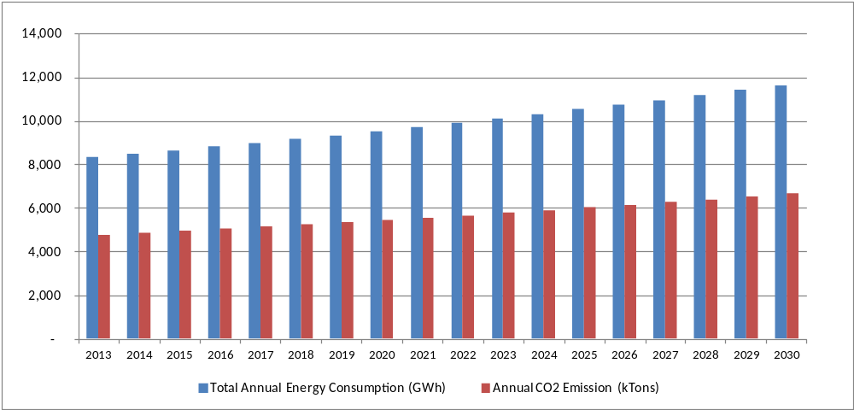
Figure 5: Estimation of Annual Energy Consumption and GHG Emission by the Construction Sector, 2013 - 2030

STRATEGY

Project rational and policy conformity
- The proposed project is in line with the Government of Mongolia (GOM) policies and measures to mitigate GHG emission. The State Policy on Energy (Parliament resolution No 63, 2015) stated that GOM sets target to reduce building heat loss by 20% by 2020 and 40% by 2030, compared to 2014 levels. The Technology Needs Assessment (TNA) 2013 provides specific measures to realize this goal by improving insulation for existing panel apartment buildings of 18,184 households in UB. The investment needed is estimated at 90 million USD.

- Moreover, the project will contribute to the achievement of the Green Development Policy’s Objective 1 “Promote resource efficient, low greenhouse gas emission and wasteless production and services”. The project also addresses the Sustainable Development Goal (SDG) 7, 11 and 13. NAMAs in Construction Sector in Mongolia proposes to support GOM’s NAMA intent to the UNFCCC. Mongolia’s NAMA concepts identify 21 mitigation options in four major GHG emitting sectors including energy, industrial process, agriculture, and forestry. Out of these concepts, four focus on energy efficiency in the construction sector.

- The comparative advantage of UNDP in implementing this project is its experience in integrated policy development, human resources development, institutional strengthening, and non-governmental and community participation.

Country ownership: Country Eligibility
- The project fits the objectives of GEF Operational Program 5 and will contribute to the reduction of greenhouse gas emissions through the establishment of baseline energy consumption and GHG emission in the construction sector and monitoring, reporting and verification (MRV) to support the development of NAMA projects. These processes will help stimulate the investment of NAMA in the construction sector. Mongolia adopted the UNFCCC on 30 September 1993.

Country Drivenness
- In recognition of the critical role of building energy usage on GHG emission and air pollution, the Government of Mongolia continues to support large numbers of related projects, assisted by international donors, to improve urban district heating and HOBs energy efficiency, reduce heat losses distribution network, improve quality of fuel and stoves in Ger, and promote Ger insulation blankets. With a focus on poverty reduction, these previous projects contribute largely to the energy use in Ger. With the population trend moving from Ger to apartment buildings, recent projects have started to shift the focus to the housing sector. The UNDP-GEF BEEP had also improved the BCNS and built capacity for compliance of the building codes. However, there are still significant works to continue the effort on BCNS enforcement, particularly in the large property development for the middle income population. Inadequate design and insulation of these buildings will result in great energy demand as they would need to meet the comfort of the middle income population. The significance of energy demand is this sector has not been addressed as full compliance with the improved EE BCNS is yet to be achieved.

- The government policy goals and targets in relation to energy efficiency in the construction sector is the National Action Program on Climate Change (approved by parliament in 2011), duration 2011 -2021. The specific targets include:
- Specific fuel consumption of electricity generated in the Central Energy System (CES) will be reduced by 10-20 kJ/kWh.
- Specific consumption of thermal energy production will be reduced by 20 kJ/gcal compared to 2010
- Share of RE sources in the energy balance will reach 10%
- Heat use will be reduced by 25%.

- The recently approved Energy Conservation (EC) Law mandates large energy consumers to undergo energy audit and to report annually its energy consumption as well as its plans and activities to reduce their energy consumption. The Energy Conservation Council will be established for regulating and implementing the policies on energy conservation nationwide. Reports from the Designated Consumers/Entities are to be submitted to the Energy Conservation Council. The council will operate under the direction of the Energy Regulatory Commission (ERC). Since the EC Law requires large energy users to conduct an energy audit in its facilities, capacity building of local resources on energy audits is a critical component in the implementation of the EC Law. It is not yet final when the work on the development of the rules and regulations will start.

- In addition, the State Great Khural (Parliament of Mongolia) has passed the Green Development Policy of Mongolia on June 13, 2014 with 6 objectives. This project directly addresses Strategic Objective#1, i.e., Promote resource efficient, low greenhouse gas emission and wasteless production and services.

Alternative Scenario
- Complementing the baseline projects, the GEF Project aims to develop an ‘umbrella’ approach that will incentivize low emission and sustainable development in the construction sector in Mongolia. It takes a comprehensive approach and expands the operational and financial scope of the previous and ongoing projects, such as the UNDP-GEF BEEP, to cover additional and more ambitious target areas. It is envisioned that this approach to efficient buildings could, in the future, be nested into a more holistic approach to the urban sustainable development. Therefore, a NAMA in the context of the proposed project offers a framework to achieve broad based and comprehensive climate change mitigation activities. The Project is structured around three components anticipated to support the achievement of the project objective, i.e. to facilitate market transformation for energy efficiency in the construction sector through the development and implementation of NAMA.

- The alternative scenario induced by the Project will most likely be characterized by the following:

- Through establishment of energy consumption and GHG emission database systems, which will complement the recently approved EC Law, the policy makers in Mongolia are fully aware of EE potential in the construction sector, and commit to more stringent enforcement of the BCNS, and all new buildings meet 100% of the BCNS requirements.
- Improved confidence in benefits (economic, environmental and social) of applying of basic and commercially best available EE technologies to meet or even go beyond the BCNS EE requirements in all building types through proven results from a number of successful building demonstration projects based on practical and accurate MRV systems.
- Enhanced awareness and strengthened capacity within private and public actors and financial institutions on basic and “beyond code” EE building designs, as well as NAMA development and implementation through a number of capacity development activities and dissemination of project successes, among others.
- New and improved fiscal incentives, financial products, as well as financial evaluation tools to support EE in the construction sector are introduced stimulating building owners/managers’ interest in EE investments. Construction of curtain wall buildings are code compliant with triple (or ideally quadruple – 4 pane) glass with low-e and argon or krypton gas fill and insulated glazing framing elements and insulation of any non-transparent glazing façade elements.

Most of the new buildings that will be built in Mongolia will adopt better design approaches and commercially best available EE technologies to fully comply with, or even more efficient than the BCNS EE requirements. This will reduce the energy intensity from 165 kWh/m²-yr to a level 155 kWh/m²-yr as measured by BEEP. The percentage of new buildings which are fully compliant with the BCNS EE requirements will increase to 100% by end-of-project. In addition, 5% of the new buildings will go beyond the code requirements and achieve 20% lower energy intensity than the full compliant level. This is possible considering that the newly approved EC Law has legitimized the EE requirements in Mongolia, and EE construction materials and equipment are also locally available and accessible. This will be reinforced through the adoption of supporting MRV systems, together with the capacity building programs. Moreover, it is also envisaged that, through the results of new financial mechanism, demonstration projects and dissemination activities, the percentage of the total building stock to implement EE projects will dramatically increase by end-of-project.
- The estimated annual electricity and GHG emission savings from the construction sector in Mongolia by end-of-project in 2020 will be 18.7 GWh, and 10,709 tCO2e respectively. Table 9 summarizes direct and cumulative electricity and GHG emission savings estimated based on the GEF EE Tool.

Table 9: Projected Electricity and GHG Emission Savings
Parameter | Annual |  | Cumulative
Parameter | 2017 | 2020 | 2017-2020 | 2021-2030
Direct Electricity Savings (MWh) | 512 | 9,355 | 18,722 | 93,549
Direct GHG Emission Savings (tCO2) | 293 | 5,351 | 10,709 | 53,510
Indirect Bottom-up Emission Savings (tCO2) |  |  |  | 57,435
Indirect Top-down Emission Savings (tCO2) |  |  |  | 438,926

Project objectives, outcomes and outputs
- The objective of this project is to facilitate market transformation for energy efficiency in the construction sector through the development and implementation of NAMA. The project comprises 3 components

- Component 1: Establishment of Baseline Energy Consumption and GHG Emission in the Construction Sector
- Component 2: Development and Implementation of NAMA in the Construction Sector
- Component 3: Measurement, Reporting and Verification (MRV) system for NAMA
The abovementioned components will address the barriers discussed in the barrier analysis section, and expected outcomes of the three components are the following:
- Effective EE policy making informed by robust energy consumption monitoring and reference baselines for the construction sector
- Prioritized NAMA in the construction sector developed and funded for implementation
- Effective climate change mitigation policies strengthened by NAMA impacts ascertained through the established MRV system

The abovementioned outcomes will all collectively lead to greater implementation of NAMA in the construction sector in Mongolia, and will be realized through the delivery of complementary outputs that would result from the activities that will be carried out under the Project. Details on outcomes, outputs and activities of each component are discussed under the project activities section.

Component 1: Establishment of Baseline Energy Consumption and GHG Emission in the Construction Sector (Total Cost USD 800,000; GEF Assistance USD 200,000)
- Developing sector specific inventory systems can strengthen a country’s overall measurement abilities when the same processes are standardized and applied across other dimensions of GHG mitigation actions. The successful implementation of the activities under this component will deliver the necessary outputs that will contribute to the realization of the following expected outcomes: Effective policy making informed by robust energy consumption monitoring and reference baselines for the construction sector. This component will contribute towards significant enhancements to the national GHG inventory of the energy end use sector. The respective outputs of the outcomes under Component 1 are summarized in Table 10.
Table 10: Summary of expected outcomes, outputs and activities under Component 1
Expected Outcomes | Expected Outputs | Activities
Outcome 1: Effective EE policy making informed by robust energy consumption monitoring and reference baselines for the construction sector | Output 1.1: Designed and completed capacity building development programs for decision makers and agencies on data collection and sustainable operation of the GHG inventory systems | • Activity 1.1.1: Develop training modules targeting decision makers on the imperative of data collection and GHG inventory system  • Activity 1.1.2: Develop training modules targeting technical staff on data collection, establishment and operation of the GHG Inventory System  • Activity 1.1.3: Implement the training programmes  • Activity 1.1.4: Conduct post training evaluation survey
 | Output 1.2: Established and operational energy consumption and GHG inventory system for the construction sector with improved data availability and methodology | • Activity 1.2.1: Review existing national communications data inventory system to identify barriers, gaps, needs, lessons and challenges for data collection and compilation  • Activity 1.2.2: Formulate GHG inventory protocols and procedures for the construction sector  • Activity 1.2.3: Identify and select key focal points for the collection, compilation and management of baseline data  • Activity 1.2.4: Develop institutional arrangements, and coordinate procedures among a broad range of stakeholders engaged in the construction sector  • Activity 1.2.5: Collect, compile, quality check and analyze data  • Activity 1.2.6: Develop and test the inventory system and deploy a web-based data collection system  • Activity 1.2.7: Develop and implement guidelines to regularly update and improve the inventory system  • Activity 1.2.8: Develop and conduct training programs for data management staff to strengthen the data collection efforts for inventory at the energy end-use sectoral level
 | Output 1.3: Defined and established reference baseline on energy consumption and GHG emission for the construction sector | • Activity 1.3.1: In partnership with national communication inventory team, define and develop parameters for reference baseline and emissions boundary  • Activity 1.3.2: Estimate the reference baseline for energy consumption and associated GHG emissions  • Activity 1.3.3: Test, verify and establish reference baselines for energy consumption in different types of buildings and GHG emissions in UB

Output 1.1: Designed and completed capacity building development programs for decision makers and agencies on data collection and sustainable operation of the GHG inventory systems
- There is no ongoing baseline effort on the collection and formulation of GHG inventory systems at the sub-sector levels. Considering this, incremental GEF assistance is required for design and implementation of capacity building development programs for decision makers and agencies who will be engaged in collecting data necessary for establishment and operation of the GHG inventory systems. To deliver this output, the following activities will be carried out:

- Activity 1.1.1: Develop training modules targeting decision makers on the imperative of data collection and GHG Inventory System – One training module will be formulated explicitly targeting decision makers at key agencies on the imperative of systematic data collection and sub-sector level GHG inventory. The training will provide necessary platform not only to enhance awareness and understanding but also to secure high level buy in and identify champions from the key agencies.

- Activity 1.1.2: Develop training modules targeting technical staff on data collection, establishment and operation of the GHG Inventory System - Two training modules addressing skills required in data collection and validation, and knowledge in establishment and operation of the GHG inventory system will be designed. The training modules will emphasize on practical training to ensure that the relevant agencies and its technical staff will be able to perform the necessary tasks.

- Activity 1.1.3: Implement the training programmes – To ensure effectiveness of the training program, the training for each module will target no more than 15 participants. Criteria of selection of trainees will be consulted with relevant agencies, and trainees nominated by each agency (e.g. staff from CDC, MoE, National Statistics Office, Major City governments, MEDGT and local GHG consultants) will be assessed for their basic skills and knowledge for each training module. The training program will be conducted at the early stage of project implementation, as the capacity built by the training program is required for implementation of activities under subsequent outputs.

- Activity 1.1.4: Conduct post training evaluation survey of individuals that participated in the above trainings. The purpose of the survey is to gather information on whether individuals are applying what they’ve learned through the training, and will be conducted towards the end of project.

Output 1.2: Established and operational energy consumption and GHG inventory system for the construction sector with improved data availability and methodology
- Preparation of the Third National Communication under UNFCCC is underway by MEDGT and expected to complete in 2017. It is not yet clear if the Third National Communication will provide details at the sub-sector level, however, the Second National Communication submitted in 2010 provides details on GHG emissions only at the sector level (e.g., Energy, Transport, etc.). The project will collaborate with MEDGT and the output will be integrated with the works undertaken by the National Communication consultant who is preparing the Third National Communication. Incremental GEF assistance is required for the following activities.

- Activity 1.2.1: Review existing national communications data inventory system to identify barriers, gaps, needs, lessons and challenges for data collection and compilation – This activity involves conduct of a comprehensive data collection available to support the analysis of the construction sector energy consumption employing existing data and local stakeholders’ support particularly from the Ministry of Energy (MOE) and utilities. Data will be classified by types of energy (electricity and heat energy) and by building types: residential, commercial and public buildings. In a similar manner, buildings stock data will be collected, classified and mapped out with the energy consumption data. These data will be analyzed to determine gaps and shortcomings for the construction sector’s energy consumption and GHG inventory to be built and developed in subsequent activities.

- Activity 1.2.2: Formulate GHG inventory protocols and procedures for the construction sector – This involves developing standardized methodologies for undertaking inventories in line with international best practices and realities on the ground. To set up the GHG inventory for the construction sector, a formulation of systematic protocols and procedures need to be clarified including boundary, scope, key analysis methodology and documentation. For the NAMA in Construction Sector project, the scope covers only multi-story buildings and private housing estates connected to the heat and electricity grid, and the boundary for GHG emission inventory and accounting will be confined to only electrical and heat energy use in these buildings. The methodology and protocols will be tested and refined in subsequent activities and later adopted by the government for official use.

- Activity 1.2.3: Identify and select key focal points for the collection, compilation and management of baseline data – The focal points within each key stakeholder will be identified and consulted to refine the GHG inventory protocols and procedures.

- Activity 1.2.4: Develop institutional arrangements, and coordinate procedures among a broad range of stakeholders engaged in the construction sector - Institutional Arrangements (IA) will be established with the purpose: (1) to ensure that the resources and legal authority, which are necessary to perform the required functions are available; and (2) to set a framework of provisions which rule those functions. The functions of IA will be classified into those related to inventory planning, preparation, and management. It is envisioned that the Ministry of Environment, Green Development and Tourism of Mongolia (MEGDT) will lead the IA with support and participation from Ministry of Energy (MOE) and Ministry of Construction and Urban Development (MCUD).

- Activity 1.2.5: Collect, compile, quality check and analyze data – Following the IA development, necessary data will be collected and compiled including commissioning of survey to gather information on building operators’/owners characteristics which determine energy consumption pattern, and then validated and analyzed by the project. It must be noted that the information presented in the National Communications and BURs are gathered at the sectoral and national levels. Therefore this project will allow the country to generate much more specific inventories at the sub-sectoral level.

- Activity 1.2.6: Develop and test the inventory system and deploy a web-based data collection system – A web-based inventory system will be developed based on availability and structure of data. A prototype and beta version for testing will be constructed to ensure that sufficient reviews and improvements can be made before conclusion.

- Activity 1.2.7: Develop and implement guidelines to regularly update and improve the inventory system – Following the finalization of the web-based inventory system, operating and upgrading guidelines will be prepared to ensure regular update and periodical review and improvement are well understood. These will include a recommendation on effective communication methods for MEGDT to establish regular contacts with all the key stakeholders (e.g., MUCD, MOE, property developers, etc.) that will provide meaningful data related to the construction sector.

- Activity 1.2.8: Develop and conduct training programs for data management staff to strengthen the data collection efforts for inventory at the energy end-use sub-sectoral level – The training program for data management staff will be prepared and conducted. The guidelines developed by activity 1.2.7 will be used as the knowledge products for the training.

Output 1.3: Defined and established reference baseline on energy consumption and GHG emission for the construction sector
- This output targets to establish reference baseline with actual data collection and protocols from Output 1.2. Relevant reference baselines on energy consumption and GHG emission for the construction sector in Mongolia have been prepared in an ad-hoc manner to respond requirements of specific projects. Under this output, the project plans to collaborate with the thermo-technical rehabilitation project in public and apartment buildings in Ulaanbaatar, to enhance integrity of reference baseline data for specific types of buildings available from the said project. Incremental GEF assistance is required for establishment of reference baselines and GHG inventory for the construction sector. To deliver this output, the following activities will be undertaken:

- Activity 1.3.1: In partnership with national communication inventory team, define and develop parameters for reference baseline and emissions boundary – Parameters for the reference baseline for heat and electrical energy consumption, and respective emission boundary and inventory for the construction sector will be developed and then categorized into residential and non-residential based on existing energy data. The subcategory of these buildings and their definitions will be discussed with MCUD, MOE and MEGDT to set reference classification for future used.

- Activity 1.3.2: Estimate the reference baseline for energy consumption and associated GHG emissions - The reference baseline for the construction sector in Mongolia will be established for 2016 with projection to 2030. The reference baseline in 2015 will use the most up-to-date information gathered during Activity 1.2.1.

- Activity 1.3.3: Test, verify and establish reference baselines for energy consumption in different types of buildings and GHG emissions in UB - The reference baseline of energy consumption and GHG emission in the construction sector in Mongolia will be established. More up-to-date values of emission factor recognized by the Government of Mongolia will be reviewed and referenced as appropriate.

Component 2: Development and Implementation of NAMA in the Construction Sector (Total Cost USD 4,705,110; GEF Assistance USD 821,022)

- This component responds to the underlying policy, market and investment barriers to the development and implementation of feasible scaled up mitigation actions. The successful delivery of the outputs from the activities under this component will contribute to the development and implementation of prioritized NAMAs in the construction sector. The designed NAMA will be built on the success of the previous UNDP-GEF BEEP which laid a foundation on the EE building code (the BCNS system) in Mongolia. The mitigation actions will also be strengthened by promoting beyond-the-code building designs, and applications of advanced EE technologies for the construction sector. Key activities under this component will include prioritization of energy efficiency measures and enabling market environment that will subsequently attract investments from the private sector. The respective outputs of the outcomes under Component 2 are summarized in Table 11.
Table 11: Summary of expected outcomes, outputs and activities under Component 2
Expected Outcomes | Expected Outputs | Activities
Outcome 2: Prioritized NAMA in the construction sector developed and funded for implementation | Output 2.1: Developed framework for evaluating appropriate climate change mitigation interventions; and identified priority climate change mitigation actions | • Activity 2.1.1: Develop methodology/standardized approach for preparing and updating abatement cost curves  • Activity 2.1.2: Develop detailed marginal abatement cost curves (MACCs)  • Activity 2.1.3: Develop training program and annual budget on the use and management of MACCs  • Activity 2.1.4: Develop and implement selection criteria for prioritization of the most cost effective measures for inclusion in the NAMA  • Activity 2.1.5: Conduct policy studies to recommend a concerted policy framework to support implementation of priority measures
 | Output 2.2: Completed operational structure for coordination among government agencies and key stakeholders for NAMA | • Activity 2.2.1: Review and assess best practices and recommend options for institutional arrangements (IA) for NAMA development and implementation  • Activity 2.2.2: Define roles and responsibilities of the entities that will be a part of the IA  • Activity 2.2.3: Conduct stakeholder consultations to solicit feedback, refine and endorse the IA from supporting entities and stakeholders
 | Output 2.3: Completed capacity development of private and public sector actors on successful development and implementation of NAMAs; and in the supportive identification of financing options | • Activity 2.3.1: Conduct need assessment and design of capacity development programs for private and public sector  • Activity 2.3.2: Execute capacity development trainings for private and public sector participants to evaluate, formulate, implement and access financing for the NAMA
 | Output 2.4: Developed and implemented construction sector pilot NAMA | • Activity 2.4.1: Finalise demonstration projects and conduct detailed energy audits  • Activity 2.4.2: Prepare detailed design and implementation plans for each demonstration host  • Activities 2.4.3: Procure energy efficient technologies and energy monitoring systems  • Activity 2.4.4: Install and commission energy efficient technologies/applications for demonstration projects  • Activity 2.4.5: Evaluate the pilot NAMA and develop criteria for categorizing NAMA as supported or voluntary  • Activity 2.4.6: Clearly document and disseminate results and lessons from the demonstration projects
 | Output 2.5: Developed financial tools that support the implementation of NAMA in the construction sector | • Activity 2.5.1: Detailed feasibility analysis on NAMA financing options  • Activity 2.5.2: Design and implement financial instruments to support scaled EE investments and measures

Output 2.1: Developed frameworks for evaluating appropriate climate change mitigation interventions; and identified priority climate change mitigation actions
- This output will be crafted based on the recent Technology Needs Assessment (TNA) report prepared by MEGDT. Incremental GEF assistance is required for prioritization of mitigation actions, and development of a concerted policy framework to support NAMA implementation. To deliver this output, the following activities will be carried out:

- Activity 2.1.1: Develop methodology/standardized approach for preparing and updating abatement cost curves– Methodologies/standardized approaches will be developed in line with international best practices and on the ground realities for formulation of GHG marginal abatement cost curves. The Project will work with both international and national experts with the long term goal of building local capacity to provide support for abatement potential and cost curve analysis that could be adapted in the future to additional provinces and other sub-sectors. The activity will develop a strategy to upgrade and update the MACCs on a regular basis.

- Activity 2.1.2: Develop detailed marginal abatement cost curves (MACCs)– This activity will conduct review of the list of technologies included in the TNA report, and update all relevant figures as required. The results of the review and update will be use to develop marginal cost curves for all priority technologies and applications. Note that for each particular group of technologies, variation in technology types and quality will be evaluated to ensure that detailed marginal cost curves are adequately developed.

- Activity 2.1.3: Develop training program and annual budget on the use and management of MACCs: Training program will be developed and conducted to enhance the technical capacity of the local experts in the use and management of the MACC tools. Lessons learned from activity 2.1.1 and 2.1.2 will be documented for sharing with other experts.

- Activity 2.1.4 Develop and implement selection criteria for prioritization of the most cost effective measures for inclusion in the NAMA – Based on the detailed MACCs selection criteria for prioritization of the most cost effective measure for the construction sector NAMA will be developed and consulted with key stakeholders before finalization.

- Activity 2.1.5: Conduct policy studies to recommend a concerted policy framework to support implementation of priority measures - The policy studies will define potential fiscal and non-fiscal policy incentives and measures to support implementation of priority EE measures in Mongolia. Fiscal policy incentives and measures may include tax credit, subsidy for EE measures, and innovative financial products for EE in the construction sector, while non-fiscal policy measures may include technical assistance, awareness and capacity buildings. Recommendations on these policy incentives and measures would include the followings:
- Subsidizing/rebate cost of insulation materials and EE appliances
- Innovative financial products and guarantee facilities for EE investment in new and retrofitted buildings
- Strengthening enforcement of BCNS EE requirements through capacity building and technical assistance for developers and contractors
- Aggressive promotion and uptake of Building Label
- Tax credit for apartments/buildings that apply mitigation actions
- Reform of heat energy tariff to actual consumption based heat tariff
- Establishment of Energy Conservation Fund from fuel/coal tax to finance mitigation actions
The above policy incentives and measures will be discussed and packaged to support NAMA actions in the construction sector, and integrated into relevant project activities (e.g., capacity building).
Output 2.2: Completed operational structure for coordination among government agencies and key stakeholders for NAMA
- Implementation arrangements including the institutional set-up is crucial to the success of the NAMA. Under this output, relevant operational structures for NAMA as recommended by the ongoing Capacity Building Projects for NAMAs Project implemented by MEGDT will serve as a basis for the development of the operational structure for the construction sector NAMA. Incremental GEF assistance is required for detailed assessment and facilitating the adoption of institutional arrangements for the construction sector NAMA, and the following activities will be carried out:

- Activity 2.2.1: Review and assess best practices and recommend options for institutional arrangements (IA) for NAMA development and implementation - This activity will focus on the assessment of capacity and capability (such as human resource, financial resource, technical capability, and other resources required) in the development and implementation of NAMA for all relevant agencies. It is foreseen that the two key agencies taking the lead role in the construction sector NAMA are MCUD and MEGDT. However, it is envisioned that MOE and the Ministry of Finance (MOF) will also play critical roles in the arrangement as several potential policy incentives and measures for the construction sector NAMA are likely to fall under the remit of these two ministries. Other public agencies to be included in the assessment would include UB City, local authorities, university and industry associations (e.g., School of Civil Engineering and Architecture, Windows Manufacturer Association). In addition to the public sector agencies, potential private sector actors such as construction sector fraternity including property developers, building practitioners (e.g., architects and engineers), material and technology suppliers, and financial institutions, will also be included in the scope of assessment.

- Activity 2.2.2: Define roles and responsibilities of the entities that will be a part of the IA - The roles, responsibilities and process of interaction of the stakeholders involved in development and implementation of NAMA will be clearly defined. The description of the organizational structure of the NAMA will be elaborated and consider (a) governing structure, the entities involved and their respective roles and responsibilities; and (b) key institutions and entities responsible for administering and enforcing any included regulatory initiatives. Dedicated effort will be made to ensure that men and women staff are equitably represented in the IA structure.

- Activity 2.2.3: Conduct stakeholder consultations to solicit feedback, refine and endorse the IA from supporting entities and stakeholders – Consultation meetings will be organized with the stakeholders to present the draft implementation structure, solicit feedback and table the implementation arrangement for endorsement. It is envisioned that all key responsible parties will endorse the IA as an indication of their commitment and support towards the construction sector NAMA.

Output 2.3: Completed capacity development of private and public sector actors on successful development and implementation of NAMAs and in the supportive identification of financing options
- The scope of baseline activities under the ongoing Capacity Building Projects for NAMAs Project implemented by MEGDT will be expanded and complemented by the incremental GEF assistance, specifically in the financing of the NAMA. To deliver this output, the following activities will be carried out.

- Activity 2.3.1: Conduct need assessment and design of capacity development programs for private and public sector - Although NAMA in the construction sector has already been included in the Mongolia NAMA Database, capacity of those public and private actors identified in output 2 - to evaluate, formulate, implement and finance the construction sector NAMA - need to be strengthened. The project will conduct a needs assessment to identify knowledge gaps and training needs for private and public actors. Following the needs assessment, a training course incorporating design guidelines and methodology, mitigation technologies and measures, MRV and financing options will be developed together with a complete work plan, resources required, and appropriate Monitoring and Evaluation (M&E) frameworks. It is envisioned that the capacity development programs will comprise classroom lectures, exercises, and field visits/activities.

- Activity 2.3.2: Execute capacity development trainings for private and public sector participants to evaluate, formulate, implement and access financing for the NAMA– The training will be implemented in accordance with the work plan, and it is envisioned that the training program will be conducted as a series of training workshops in an intermittent manner over a period 2-3 months. Specifically, the workshops on construction sector NAMA financing will focus on actual financial tools developed under output 2.5 and fiscal policy measures identified under output 2.1.
Output 2.4: Developed and implemented construction sector pilot NAMA
- This output aims to demonstrate successful implementation of pilot NAMA that constitutes a combination of new and retrofitted buildings complying fully with the existing energy codes as well as those that go beyond-the-code requirements. The following activities will be carried out to deliver this output:

- Activity 2.4.1: Finalise demonstration projects and conduct detailed energy audits - During the project formulation stage demonstration projects have been identified, as shown in Table 12. These will be the initial cohort of demonstration projects that will be used to pilot the concept and test some of the key characteristics of a NAMA project, in a generally easier and more controlled way. At project inception additional demonstration projects may be solicited, evaluated and finalized, subject to co-financing commitments. According to the project strategy, demonstrations will represent major advancement towards achieving full energy code compliance and beyond-the-code requirements. For the latter, in particular, best available energy efficient technologies will be demonstrated that are much more advanced than the ones applied currently in the baseline scenario.

Implementation of the proposed mitigation actions in the School of Civil Engineering and Architecture (SCEA) covers both new and existing buildings, while the proposed mitigation actions in Soum will be on existing systems. Additional details of applicable EE technologies for these demonstration projects that officially confirmed their co-financing commitments are given in Annex I. The pre-feasibility analyses that were conducted during the project preparation phase will be reviewed and verified as will the pre-identified energy efficiency measures. Detailed energy audits will then be conducted with support from the Project and the demonstration hosts. The initial scope of detailed energy audit includes: 1) analysis of current energy use and operating costs, and establishment of energy balance and baseline; 2) detailed study of existing equipment/ systems/ operations that offer opportunities for energy saving; 3) evaluation of saving type and potential including guaranteed amount; 4) required finance to implement recommended EE measures including a cash flow projection for the project.

It should be noted that a detailed energy audit will generally provide a series of energy efficiency measures, prioritized based on technical and economic evaluations. The results from the MACC prepared in component 1 will guide the selection of the most appropriate technologies and applications for the pilot NAMA.

- Activity 2.4.2: Prepare detailed design and implementation plans for each demonstration host - After the project inception phase, detailed engineering designs with technical specifications, comprehensive technical and economic evaluations for the recommended EE implementation will be carried out. Best available EE technologies will be considered with technical and economic justifications. MRV protocols for each demonstration project will be based on Component 3, and, instruments and equipment necessary for MRV activities will also be included in the final design documents.

Prior to the installation and commissioning of the energy efficiency measures in each demonstration building, a four year implementation plan for each demonstration will be prepared to facilitate smooth and effective implementation within a realistic implementation timeline. The plan will include, among others: a) availability and scope of technical assistance for implementation of demonstration projects from the Project and other sources; b) appropriate financing assistance available from local and international sources, including the financial instruments to be available under output 2.5 and; c) availability and capacity of EE technology suppliers and service providers that could support operation and maintenance of installed technologies and systems to prolong EE performance. A draft plan will be discussed with the each demonstration host prior to adoption for the implementation phase. Drawing from the early lessons learned from the demonstration projects the implementation plan, will be form a basis to formulate an overall implementation framework for future demonstration projects that are anticipated to participate in the NAMA.

- Activities 2.4.3: Procure energy efficient technologies and energy monitoring systems - After conclusion of the engineering designs, the demonstration hosts will be assisted in all necessary steps that will enable successful procurements of the chosen EE technologies and applications, including but not limited to short listing of potential suppliers, and developing criteria for evaluation and selection of qualified EE technologies and systems.

Table 12: Pilot NAMA Demonstrations
Pilot Project Host | Scope of NAMA Actions | Potential energy saving
The School of Civil Engineering and Architecture (SCEA) | Retrofit the existing building of SCEA to demonstrate full compliance with the BCNS EE requirements with following EE technologies:  - Replace existing double glazed windows with more efficient triple glazed windows (see Annex I, Table A)  - Install energy efficient insulation (see Annex I, Table E) on the existing non-insulated wall (58cm light weight concrete block) | 581 MWh/yr
New laboratory building of the School of Civil Engineering and Architecture (SCEA) | Improve EE design of the new laboratory building to demonstrate beyond-the-code EE performance with following EE technologies:  - Install energy efficient triple-glazed windows (see Annex I, Table A)  - Install EE ventilation system with heat recovery mechanical control providing 50% energy saving (see Annex I, Table B)  - Install Solar PV to power lighting and ventilation systems in restrooms (see Annex I, Table J) | 65 MWh/yr
Central heating system of Soum, MCUD | Retrofit the existing central heating system of Soum with following EE technologies:  - Replace Heat only Boiler (HOB) with EE boiler with more than 75% combustion efficiency (see Annex I, Table D)  - Retrofit existing pipeline for heating network with new insulated pipeline  - Install variable speed drives for pumping station  - Install boiler feed water treatment units (the existing boiler is not equipped with treatment systems for feed water)  - Install individual heating substation | 281 MWh/yr
New Commercial Building, Windows Manufacturer Association | Install highly insulated curtain wall systems sourced locally or produced by local manufacturers (see Annex I, Table C) in a newly constructed building to be identified in collaboration with the Windows Manufacturer Association | 30% from estimated baseline

- Activity 2.4.4: Install and commission energy efficient technologies/applications for demonstration projects - Following delivery of EE equipment and systems to the project site, the demonstration hosts will be supported in the installation and commissioning of EE equipment and systems. Key issues during the installation phase that could impact energy efficiency and operating performance and durability (lifetime) of EE equipment and systems, such as ambient temperature, ventilation, relevant civil and mechanical works, will be reviewed and confirmed by the project.

Installation of instruments and equipment for MRV activities will be carried out before implementation of energy efficient technologies/applications, and baseline data for each pilot demonstration will be gathered by the demonstration host with supports from the project. For retrofitted buildings, these will include, but not necessarily limited to, compilation of historical energy consumptions, installation of measuring instruments/equipment, operating performance (level of activities and services delivered). For new EE commercial buildings, these will include evaluation of design specifications, and design energy consumption. The performance targets for each demonstration project will also be established vis-à-vis the estimations in detailed design.

After completion of the commissioning and test-run period, post-installation monitoring of each demonstration in accordance with the MRV plan will be carried out by the demonstration host. All parameters gathered during the pre-installation phase (baseline) will be monitored and recorded. These MRV activities will be carried out in collaboration with Construction Development Center (CDC) to enhance direct experience on monitoring and verification of BCNS compliance of buildings under actual operation. It is envisioned that this will serve as a platform for CDC in strengthening their inspection and compliance capabilities for future activities.

- Activity 2.4.5 Evaluate the pilot NAMA and develop criteria for categorizing NAMA as supported or voluntary- Based on results and impacts of the demonstration projects, the pilot NAMA will be evaluated and adjusted before rolling it out as a full-fledged NAMA. Criteria for categorizing NAMA as supported or voluntary will be prepared and the pilot NAMA will be assessed against those criteria to determine whether the full fledged NAMA could be categorized as voluntary or supported at the UNFCCC NAMA registry.

- Activity 2.4.6: Clearly document and disseminate results and lessons from the demonstration projects - Documentation of findings from the operation and monitoring of the demonstration projects will be prepared. At least two case studies of all demonstration projects will be separately prepared, one before mid-term review and the other before terminal evaluation. Wherever possible, discussion on sustaining energy savings, minimizing possible rebound effects, and comparing similar EE implementations in other countries will be included in the case studies. These documents will cover both technical results of operations as well as results of the development impacts surveys conducted by the project. Development impacts of the project will comprise non-energy benefits such as employment secured, costs saved, income generated, gender impacts to name a few. A distinct communication strategy including a dissemination plan will be prepared in the first year of the Project and guide the communication and dissemination of results throughout the Project and possibly beyond. A project website will also be prepared and maintained where these documents will be uploaded. In addition to print materials, at least two video/documentaries/short films highlighting successes and lessons including socio-economic impacts of the demonstration projects will be prepared and disseminated.
Output 2.5: Developed financial tools that support the implementation of NAMA in the construction sector
- This output will be developed in collaboration with relevant baseline activities (e.g., the Eco Loan Program), and it will be delivered through evaluation and design of innovative financial tools for the construction sector NAMA. The primary focus of the financing support would be buildings that are more efficient than a typical building compliant with BCNS and demonstrate beyond-the-code compliance. This would also include support for early adopters of best available EE technologies in combination with renewable applications (e.g. solar PV lighting and solar water heaters used for space heating). It should be noted that the consultations during project formulation stage with the government, local financial sector and construction sector fraternity underscores the imperative on having financial incentives and support in place to unleash the optimum potential of achieving energy efficiency and conservation in the construction sector. There is a keen interest and commitment from the local financial sector in championing this cause and taking a lead in implementing an effective financing support for the NAMA. Incremental GEF assistance is required for the following activities.

- Activity 2.5.1: Detailed feasibility analysis on NAMA financing options: A comprehensive review was conducted during the project formulation stage to analyse financing options available in the country that could potentially support NAMA in the Construction Sector. The findings indicate that high prevailing interest rate is one of the key barriers to the increased cost of financing and prohibit investments in energy efficiency measures. Hence, risk sharing mechanism, such as a partial credit guarantee or a co-financing mechanism, were identified as potential financing instruments to support the NAMA. During project inception, a detailed feasibility assessment will be conducted to validate these options.

- Activity 2.5.2: Design and implement financial instruments to support scaled EE investments and measures – Drawing from the activity 2.5.1 as well as based on the existing policy measures related to EE in the construction sector and prevailing financial barriers in Mongolia, the most plausible financial scheme will be determined that may assist in leveraging new and additional financing support for the construction sector NAMA. It will be considered for detailed design and implementation. Following the confirmation on economic justifications, a stakeholder consultation meeting will be organized to discuss and endorse selection of the financial option. This exercise will be conducted in close cooperation with and engagement from the local financial sector, relevant ministries such as Ministry of Finance and EE technology suppliers, manufacturers and property developers. A comprehensive design of the financial tool will be prepared and define, among others: the financing arrangements, mode of delivery, the project eligibility criteria and priority listing, borrower’s eligibility criteria, financing coverage, maximum loan size, interest rates, fees/charges if any, loan term, documentary requirements, timing of the delivery of the finance mechanism, the mode of recovering the losses. A financial institution where the fund mechanisms shall actually reside will be identified. A fund manager for the administration and implementation of financial mechanism will be established within a local financial institution. Once the fund secures approval, implementation will kick off, and policy and management guidelines executed. The proposed financial tools will also be referenced in the capacity building programs under output 2.3.

Component 3: Measurement, Reporting and Verification (MRV) system for NAMA (Total Cost USD 600,000; GEF Assistance USD 200,000)
- It has been widely recognized that an MRV framework is necessary for ensuring credibility and accountability of a project’s estimated GHG emission reductions. Likewise, a critical requirement for NAMAs is that actions be implemented in a measurable, reportable, and verifiable (MRV) manner. Accurate MRV is paramount for ensuring that implemented mitigation actions achieve progress towards emission targets. In addition, having a good MRV framework in place is likely to facilitate national planning, learning good practices, promote coordination and communication amongst emitting sectors and increase the likelihood of gaining international support for a NAMA. The Project will support developing a framework consisting of guidelines and methodologies for MRV of NAMAs. Under the framework of NAMA, the identity of institutions responsible for various functions is not prescribed, except that submission of NAMAs to the UNFCCC Registry must be undertaken by a national government entity. The limited experience with NAMAs to date suggests that in the early stages of NAMA identification and prioritisation top-down structures may be very efficient (e.g. often NAMAs have their foundations in national policies and regulations and are developed by ministries and agencies) and in subsequent phases stakeholder involvement should be broad-based and inclusive. In particular, for the purpose of MRV it is important that the roles, responsibilities and process of interaction of the stakeholders involved in all aspects and at all phases of the NAMA be clearly defined, including the following aspects: (a) alignment with national long-term development planning and domestic policy implementation; (b) governing structure, the entities involved and their respective roles and responsibilities; (c) financing structure; and, (d) key institutions and entities responsible for administering and enforcing any included regulatory initiatives. Recognizing the role of NAMAs to reducing GHG emissions while simultaneously promoting the country’s sustainable development objectives, the project will advocate for a broader approach to MRV that establishes metrics; specific energy consumption and GHG emissions that can be used in the construction sector. Criteria on sustainable development or non-energy benefits will be considered. Such an approach to MRV of NAMA impacts would allow policy makers to track and highlight the effects of NAMAs on catalyzing economic growth, poverty reduction and environmental conservation. The successful delivery of the outputs from the activities under this component will ensure that mitigation policies and financing strategies are effective.
Table 13: Summary of expected outcomes, outputs and activities under Component 3
Expected Outcomes | Expected Outputs | Activities
Outcome 3: Effective climate change mitigation policies strengthened by NAMA impacts ascertained through the established MRV system | Output 3.1: Defined key indicators (GHG and non-GHG) to be monitored for the selected mitigation actions | • Activity 3.1.1: Conduct in-depth assessment to determine key indicators and metrics for construction sector NAMA  • Activity 3.1.2: Establish monitoring framework and define key parameters for demonstration projects to be measured, monitored, recorded and updated on the web-based inventory system in Outcome 1
 | Output 3.2: Developed and implemented accurate MRV system for the construction sector NAMA | • Activity 3.2.1: Review best practices in MRV methodologies and guidelines based on established CDM methodologies, IPCC and UNFCCC NAMA guidelines and principles  • Activity 3.2.2: Develop MRV standards and methodologies to measure, report and verify GHG and non-GHG indicators  • Activity 3.2.3: Implement the MRV activities for the NAMA in prioritized and pilot demonstrations
 | Output 3.3: Designed and completed capacity development in the implementation and institutionalization of the MRV system | • Activity 3.3.1: Commission need assessment and design of capacity development programs for MRV practitioners  • Activity 3.3.2: Execute capacity development trainings for MRV practitioners  • Activity 3.3.3: Design and conduct a post training evaluation survey of the trainees  • Activity 3.3.4: Prepare communication and knowledge products highlighting the results of the MRV

Output 3.1: Defined key indicators (GHG and non-GHG) to monitor for the selected mitigation action
- Key indicators and metrics will be analysed and determined for both GHG and non-GHG benefits (e.g. income generated, costs saved, employment created, gender considerations, and so on). The output will be delivered through the following activities:

- Activity 3.1.1: Conduct in-depth assessment to determine key indicators and metrics for construction sector NAMA - The two main types of indicators for the construction sector NAMA are progress and impact indicators. Progress indicators track the implementation status of NAMA activities (position relative to the time frame and milestones) while impact indicators refer to the impact of outputs of NAMAs (results obtained). In-depth assessment of international experience on determining key indicators and parameters for MRV will be conducted. Approaches to measure and verify GHG and non-GHG indicators, and possible metrics for each indicator adopted in the international best practices will be reviewed and assessed. Relevant indicators applicable for the Mongolian context will be recommended which would include but not limited to: building specific energy consumption (or energy intensity); GHG emission; market share and diffusion (saturation) of mitigation technologies; % of compliance with BCNS EE requirements; development benefits.

- Activity 3.1.2: Establish monitoring framework and define key parameters for demonstration projects to be measured, monitored, recorded and updated on the web-based inventory system in Outcome 1 – A framework will be developed that clearly sets out the guiding principles for MRV of the construction sector NAMA including what to do, how to do it, who should do it and when should it be done. Based on the recommended indicators in activity 3.1.1, this activity will organize stakeholder consultation to finalize the most appropriate parameters and indicators that will be incorporated in the MRV framework. The framework will also distinguish and define a boundary for MRV. It will assess the existing institutional structures, identify responsible parties for designated organization set up such as NAMA National Registry, MRV Committee to facilitate information sharing and communication. Likewise, it will guide the formulation, responsible party and regular updates of the tracking tools. The monitoring framework for identified key paramaters will be tested during the implementation of demonstration projects under output 2.4.
Output 3.2: Developed and implemented accurate MRV system for the construction sector NAMA
- The output will be delivered by the following set of activities:

- Activity 3.2.1: Review best practices in MRV methodologies and guidelines based on established CDM methodologies, IPCC and UNFCCC NAMA guidelines and principles - This activity will focus on review of international best practices on existing MRV methodologies and protocols such as CDM methodologies, IPCC and UNFCCC NAMA guidelines and principles, and the International Performance Measurement and Verification Protocol (IPMVP). It will identify key elements that should be considered while developing MRV methodology for the NAMA.

- Activity 3.2.2: Develop MRV standard and methodologies to measure, report and verify GHG and non-GHG indicators - Draft methodologies to measure, report and verify the indicators will be formulated and circulated to stakeholders for review and comments before finalizing. The methodologies will specify data to be measured or collected, tools and instruments required, data collection frequency, detailed calculation/estimation methods, approaches for ensuring quality and reliability of data and reporting templates, among others.

- Activity 3.2.3: Implement the MRV activities for the NAMA in prioritized and pilot demonstrations - Based on the MRV methodologies and guidelines prepared above, a specific MRV system for pilot demonstration projects, together with a specific plan for implementation of MRV activities which include pre- and post-installation measurements and data collections will be packaged. Implementation of monitoring and measurements in each demonstration in accordance with the MRV plan will be carried out by the demonstration host with support from the project. During the project period, data from MRV instruments and equipment shall be periodically retrieved, e.g., every quarter, to verify performance of the EE technologies and systems installed. A project profile (as a case study) for each pilot demonstration will be prepared following the MRV implementation.

Output 3.3: Designed and completed capacity development in the implementation and institutionalization of the MRV system
- To deliver this output, the following activities will be undertaken:

- Activity 3.3.1: Commission needs assessment and design of capacity development programs for MRV practitioners - According to CDC, 11 building energy auditors have been certified by the Building Energy Efficiency Center (BEEC) to date, and these certified building energy auditors in Mongolia have potential to enhance their skills to support NAMA specific projects. Considering this, the project will conduct an assessment of capacity needs on implementation of the MRV systems for construction sector NAMA for the certified energy auditors and other potential MRV practitioners, including but not limited to, relevant technical personnel working with building developers, contractors, EE technology suppliers, government agencies, as well as other local technical individuals (engineers, building designers, architects, etc.). The capacity development program will comprise at least two training modules, i.e., basic/intermediate and advance MRV training modules. The basic/intermediate module will enable potential MRV practitioners to perform basic MRV activities and simple analysis, while the advance module will involve detailed on-site measurements and analysis of mitigation actions. The capacity development program will also discuss the institutional arrangement at the sub-sector and the project levels to operationalize MRV activities for construction sector NAMA in a cost-effective manner.

- Activity 3.3.2: Execute capacity development trainings for MRV practitioners - Implementation of the capacity development program for MRV practitioners will be scheduled to match the implementation of pilot demonstrations to enable hands-on training and on-site measurements at selected sites. Selection of trainees will follow the criteria established in consultation with stakeholders. Note that MRV responsible staff attached to the pilot demonstration projects will be given priority in participating in the training. Special efforts will also be made to encourage equitable representation of men and women technical personnel as possible. It is expected that the training will be conducted over a period of one week simultaneously with the implementation of MRV activities at the selected site. Training will comprise class-room and on-site trainings. A report incorporating all training materials and curriculum as well as the evaluation for each training module will be prepared. The documentation of each training event will be consolidated to form part of the project deliverables.

- Activity 3.3.3: Design and conduct a post training evaluation survey of the trainees – this activity will include design of survey methodology, assessment tests for the trainees to determine whether they have the requisite set of skills to conduct and update MRV systems. Tests will include hands on and written components. Qualified trainees will be certified. A survey will be prepared to monitor the non-energy (or development impact) of the training to the trainees. The survey will also gather information on the proportion of related jobs held my men and women after the successful completion of the training. The survey will be conducted towards end of project (EOP).

- Activity 3.3.4: Prepare communication and knowledge products highlighting the results of the MRV - knowledge generated from the MRV component will be used for awareness and advocacy for policy makers to showcase the benefits of measurement and verification of energy savings as well as non-energy or sustainable development benefits. At least 3 case studies of NAMA pilot projects that employ approved MRV system will be prepared and incorporated in policy documents. At least one communication product (e.g. print or audiovisual) will be prepared to assimilate the lessons from MRV of the pilot demonstration projects. A dissemination strategy will be prepared and executed for the developed communication products and case studies.

Key Indicators, Risks and Assumptions
Indicators
- The project key indicators are shown in the table below.
Table 14: Project Key Indicators
Indicator | Target
Direct cumulative CO2eq emission reduction by End-of-Project, EOP (2020) | 10,709 tCO_{2e}
Number of energy consumption and GHG emission inventory systems operational and adopted for the construction sector NAMA | 1
Number of MOU to operationalize the data collection frameworks for the energy consumption and GHG inventory system by EOP | 1
Number of public and private sector entities supporting the sustainable operation of the GHG inventory system by EOP | 3
Number of prioritized NAMA in the construction sector developed and funded for the implementation by the project by EOP | 1
Number of individual EE interventions that constitute the construction sector NAMAs by Year 4 | 4
Number of identified fully capable and qualified private and/or public sector entities that are interested in funding prioritized NAMA projects by Year 4 | 3
Number of MRV systems for construction sector emissions set up and operational by Year 2 | 1
Number of institutions adopting and operationalizing MRV systems of the pilot NAMA, by 2nd Quarter Year 3 | 2
Number of construction sector NAMA case studies using the approved MRV framework and incorporated in policy documents by EOP | 3

Risks
- Risks identified in the implementation of the Project are summarized in Table 15. The overall risk is considered moderate.
Assumptions
- The main assumptions of this Project are the:
- Continued strong government support policy on NAMA in construction sector.
- Interest remains strong in reduction of air pollution in winter among energy consumers / building sector as it has impacts on their health.
- Willingness of construction sector to comply with the building code.

Table 15: Summary of Project Risks
Description | Rating | Mitigation measures
Policy measures are not in place to fully implement NAMAs | Moderate | The project will be implemented jointly with the MEGDT, one of the four mainstream policy making Ministries that hosts the Climate Change Coordination Office. Furthermore, establishment of multi-stakeholder task forces will be ensured with representations from Government entities, academia and NGOs by decree of high-level Government bodies, in order to support setting-up of relevant regulatory mechanisms for NAMA.
Ineffective coordination that leads to overlaps and lost opportunities for synergy | Low | The project will focus on strengthening overall coordination capacity of the Climate Change Coordination Office. Regular coordination meetings with key stakeholders will be supported in order to enable a discussion platform, establish a close working relationship and avoid duplication of efforts. Continuous emphasis will be placed on maintaining synergies with the ongoing initiatives by the Government, external partners and NGOs.
Weak capacities of stakeholders for project implementation and availability of reliable and sufficient amount of data | Moderate | Systematic approach will be applied to address weakness in institutional capacities. This includes a) identifying stakeholders and conduct detailed assessment for capacity needs; b) ensuring data availability by providing necessary measurement training tools and equipment, etc.
Climate Change impacts | Moderate | According to the second national communication, the adverse impacts of climate change are linked to high concentration of population, resources and infrastructure. Adequate emphasis will be placed to enhance the resilience of the energy efficient buildings to extreme climate variability. Such thinking will be incorporated into all stages of project design and implementation. The project will fully coordinate with the climate change adaptation teams and experts in the Ministry of Environment to help authorities identify such risks and integrate appropriate response measures in the proposed mitigation actions.
The level of co-financing amount may not support the project implementation promptly and sufficiently due to inadequate private sector financial buy in. | Moderate | The project will help prepare high quality assessments, feasibility studies, investment appraisals to facilitate decision making by co-financing partners.
The construction sector may not support the idea of implementing CCM measures due to economic slowdown either on their own or through the NAMA process. | Low | The project will facilitate public private dialogue and engage the private sector early on to solicit their perspectives and needs for low carbon development.
Low level of government support in the effective enforcement or proposed policies and regulations that support the implementation of NAMAs. | Moderate | The project will initially implement the policies and guidelines to the pilot cities to gauge their effectiveness. That will assist the relevant government authorities in the finalization, approval and effective enforcement. Besides, UNDP has a track record of successfully engaging with the authorities on climate change projects. The risk can be effectively mitigated through continued provision of the on-going assistance, technical backstopping and communication to encourage commitments from the authorities.
Market demand for energy efficient building materials are low due to high initial costs compared to conventional building materials and technologies | Moderate | The project will engage large property developers in investing in energy efficient projects to increase market demand. Innovative financing mechanism and policy intervention will help subsidize the cost of the EE buildings and increase the market demand.

Benefits
- Global Benefits: The global environmental benefits are apparent in terms of CO₂ emissions reduction. Through stringent implementation of BCNS EE requirements, investments in demonstration projects and replication of investments, it is anticipated that the results of this project will prevent approximately 10,709 tCO₂e in cumulative direct emissions. This is a conservative estimate which does not include direct post project emissions reduction from financial instrument planned to be delivered through Output 2.5.

- National Benefits: NAMA in the construction sector will greatly benefit Mongolia which is one of the countries in major transition. The rapid economic expansion often put the monetary benefit on priority and put a heavy toll on environmental impact of the country. Air pollution in Ulaanbaatar is increasing at the alarming rate and threatens to the health and welfare of the population. Mongolia will have benefits from GHG emission reduction as the construction sector is one of the major GHG emission contributors. The results of this project will help Mongolia progress towards the implementation of Green Development Policy and Sustainable Development Goals.

- Socio-economic Benefits: There are several socioeconomic benefits of the Project including:
  - Long term reduction of energy cost to households help lessen household expenditure and improve their financial conditions;
  - Reduced energy usage contributes to lower demand from coal fired heat-only boilers and power plants, hence, significantly reducing air pollution. This leads to improvements in health benefits for the entire population;
  - Improved living comfort and quality of life of building occupants;
  - Reduced GHG emissions thereby reducing the long term risk of climate change;
  - Increased demand of EE construction materials/technologies which will support local manufacturers and businesses leading to better employment prospects and eventually improved local economy;
  - Improved access to energy efficiency financing in the construction sector leading to EE investments;
  - Enhanced capacities and skills of people, specifically women, employed in the construction sector.
  - The project aims to put in dedicated efforts to strengthen and enhance equal participation from women and men in the technical design and implementation of EE measures in the construction sector through capacity development trainings. Gender considerations will be equally pronounced in key decision making processes during project implementation.

Cost Effectiveness
- The GEF contribution of USD 1,269,863 will result in a cumulative direct emission reduction of 10,709 tCO_{2e} by the EOP. The cumulative direct reduction in CO2 emissions over the lifetime of the project is envisioned to be 64,219 tCO_{2e.} This translates to an approximate GEF abatement cost of US$19.8/tCO_{2e}. This estimation does not take into account indirect emissions reductions achieved through replication of technology investments and additional demonstration projects. Potential direct post project CO2 emission reductions are further anticipated to be realized from the financial instruments planned under the project.

- When comparing the estimated abatement cost of this project against alternative projects that promote EE in the building and construction sector in other countries, it is found that this project is cost effective as the abatement costs delivered by similar GEF funded building energy efficiency projects range from USD 4.3 to 37.3/ tCO_{2e}. The estimated abatement cost of this project is also in accord with the findings from the GEF/UNDP's publication, entitled "Promoting Energy Efficiency in Buildings: Lessons Learned from International Experience", which illustrates that there is a large potential for GHG emission reduction activities that cost below US$20/tCO_{2e} in non-OECD countries.

Sustainability, Replicability and Innovativeness
Sustainability
- The Project is designed to ensure that Mongolia has favorable conditions for NAMA development and implementation and the conditions are sustained well after project completion. Sustainability is an integral element of the Project activities and is ensured through the outputs of most of the project components. The Project lays a concrete foundation by championing and institutionalizing critical aspects of NAMA such as establishing reference baselines, testing MRV system and so on that other future NAMAs can draw from. Establishment of MOUs among ministries and agencies involved in the construction sector NAMA will formalize necessary platforms for ongoing implementation of those NAMA supporting elements. Sustainability will also be ensured as the project will support the financial sector to take a lead in establishing financial instruments whereby additional funding can be leveraged. This coupled with strict enforcement of the energy codes, technical guidelines on EE technology design, installation, operation and maintenance together with educated consumers, construction sector fraternity and policy/decision makers, as well as capable EE technology and service providers will help reinforcing sustainability in the long term.
Replicability
- Through implementation of pilot projects, the project can demonstrate cost effectiveness of comprehensive mitigation actions in existing buildings, new buildings and central heating systems. The key criterion that will certainly enhance replicability potential of this project is that the recommended NAMAs must be suitable with different types of buildings across the construction sector in Mongolia. The monitoring and evaluation through the established MRV systems will enhance credibility of the energy saving results and increase investor confidence in the NAMA projects. Financial institutions will also be better equipped with capacity in conducting due diligence for energy efficiency projects that will help increase the loan approval rate. The project will also support MCUD to better enforce BNCS EE requirements, and will help stimulate the demand of the EE building materials and lower the cost from the economy of scale.

Innovativeness
- The Project is a first of its kind attempt in Mongolia and one of the first, globally, to pilot-test the concept of NAMA on Energy Efficiency in the construction sector. This is also the first time in Mongolia where a concerted effort to encourage the construction sector in achieving beyond the code EE requirements. The innovativeness of the project is reinforced with its focus on development of reference baseline of energy consumption and GHG emission. No project in Mongolia has yet focused on establishing an energy end use sub-sectoral baseline that is crucial for policy planning and NAMA projects. There have been several figures for specific energy consumption in buildings such as 354, 200, and 160 kWh/m² referenced by previous building related projects. Furthermore, there is no official emission factor for Mongolia heat and electrical energy generation. With these crucial factors for energy reduction and emission been clearly addressed by relevant project outputs, Mongolia will have instruments to mainstream its energy efficiency and emission reduction targets.

PROJECT RESULTS FRAMEWORK

Section II: Project Results Framework

This project will contribute to achieving the following Country Programme Outcome as defined in CPAP or CPD: Improved sustainability of natural resources management and resilience of ecosystems and vulnerable populations to the changing climate.
Country Programme Outcome Indicators: Change in energy intensity of economy and greenhouse gas emissions per capita.
Primary applicable Key Environment and Sustainable Development Key Result Area: 1. Mainstreaming environment and energy
Applicable GEF Strategic Objective and Program: GEF-5Climate Change Objective 2: Promote Market Transformation in Industry and the Buildings Sector
Applicable GEF Expected Outcomes:
a) Appropriate policy, legal and regulatory frameworks adopted and enforced
b) Sustainable financing and delivery mechanisms established and operational
c) GHG emissions avoided
Applicable GEF Outcome Indicators:
a) EE policies and regulations are adopted and enforced
b) Volume of investment mobilized
c) Number of EE projects
d) Tonnes of CO2 equivalent avoided

Strategy | Indicator | Baseline | Targets | Source of Verification | Assumptions
GOAL: Reduced GHG emissions in the construction sector | - Cumulative CO₂ emissions reduced from start of project to End-Of-Project (EOP), (tCO₂e)  - Cumulative heat and electrical energy savings due to the Project by EOP, MWh | - 2,014  - 3,521 | - 10,709  - 18,722 | - Project final and M&E report  - Reports published by MCUD and other relevant government agencies  - Reports published by project partners (e.g. Industry/Professional Associations, Building Managements and Developers) | - Commitment to EE in the construction sector by the government remains firm.  - Participation of co-financiers and private sectors in the project remains strong  - Economic growth improved or at least remains constant
OBJECTIVE: To facilitate market transformation for energy efficiency in the construction sector through the development and implementation of NAMA | - Number of construction sector NAMA developed and implemented by EOP  - % of new buildings that are fully or beyond BCNS compliance by EOP  - Number of people gainfully employed on EE in the construction sector in Mongolia by EOP | - 0  - 80%  - 0 | - 1  - 100%  - 50 | - Project final and M&E reports  - Reports published by MCUD and other relevant government agencies  - Pilot demonstration project reports  - Reports published by project partners (e.g. Industry/Professional Associations, Building Managements and Developers) | - Commitment to EE in the building sector by the government remains firm.  - Economic growth improved or at least remains constant

COMPONENT 1: Establishment of Baseline Energy Consumption and GHG Emission in the Construction Sector
OUTCOME 1:  Effective EE policy making informed by robust energy consumption monitoring and reference baselines for the construction sector | - Number of energy consumption and GHG emission inventory systems operational and adopted for the construction sector NAMA by Year 3 | - 0 | - 1 | - Project final and M&E reports  - Reports published by MCUD, MEGDT, MOE and other relevant government agencies | - Local stakeholder support in collecting and utilizing the energy consumption and GHG inventory system remain firm
 | - Number of MOU to operationalize the data collection frameworks for the energy consumption and GHG inventory system by EOP | - 0 | - 1
 | - Number of public and private sector entities supporting the sustainable operation of the GHG inventory system by EOP | - 0 | - 4

COMPONENT 2: Development and Implementation of NAMA in the Construction Sector
OUTCOME 2:  Prioritized NAMA in the construction sector developed and funded for implementation | - Number of prioritized NAMA in the construction sector developed and funded for the implementation by the project by EOP | - 0 | - 1 | - Project final and M&E reports  - Pilot demonstration project reports | - Commitments of demonstration project hosts remain strong  - Economic growth improved or at least remains constant
 | - No. of individual EE interventions that constitute the construction sector NAMAs by Year 4 | - 1 | - 6
 | - No. of identified fully capable and qualified private and/or public sector entities that are interested in funding prioritized NAMA projects by Year 4 | - 1 | - 3

COMPONENT 3: Measurement, Reporting and Verification (MRV) system for NAMA
OUTCOME 3:  Effective climate change mitigation policies strengthened by NAMA impacts ascertained through the established MRV system | - MRV system for construction sector emissions set up and operational by Year 2 | - 0 | - 1 | - Project final and M&E reports  - Pilot demonstration project reports  - Reports published by project partners (e.g. Industry/Professional Associations, Building Managements and Developers) | - Commitments of demonstration project hosts remain strong  - Economic growth improved or at least remains constant
 | - No of institutions adopting and operationalizing MRV systems of the pilot NAMA, by 2nd Quarter Year 3 | - 0 | - 2
 | - Number of construction sector NAMA case studies using the approved MRV framework and incorporated in policy documents by EOP | - 0 | - 3

TOTAL BUDGET AND WORKPLAN
Award ID: | 86244 | Project ID(s): | 93540
Award Title: | Nationally Appropriate Mitigation Actions in the Construction Sector in Mongolia
Business Unit: | MNG10
Project Title: | Nationally Appropriate Mitigation Actions in the Construction Sector in Mongolia
PIMS no. | 5315
Implementing Partner (Executing Agency) | Ministry of Construction and Urban Development (MCUD)

GEF Outcome/Atlas Activity | Responsible Party | Fund ID | Donor Name | Atlas Budgetary Account Code | Atlas Budget Description | Amount Year 1 (USD) | Amount Year 2 (USD) | Amount Year 3 (USD) | Total (USD) | See Budget Note:
OUTCOME 1: Effective policy making informed by robust energy consumption monitoring and reference baselines for the construction sector | MCUD | 62000 | GEF | 71200 | International Consultants | 49,500 | 44,000 | 11,000 | 104,500 | 1
 |  |  |  | 71300 | Local Consultants | 44,200 | 30,600 | 10,200 | 85,000 | 2
 |  |  |  | 71600 | Travel | 2,600 | 2,600 | - | 5,200 | 3
 |  |  |  | 75700 | Training, Workshops and Conference | 2,000 | 2,000 | - | 4,000 | 4
 |  |  |  | 74500 | Miscellaneous Expenses | 1,500 | 1,500 | 1,000 | 4,000 | 5
TOTAL OUTCOME 1 |  |  |  |  |  | 99,800 | 80,700 | 22,200 | 202,700
Outcome 2: Prioritized NAMA in the construction sector developed and funded for implementation | MCUD | 62000 | GEF | 71200 | International Consultants | 11,000 | 77,000 | 33,000 | 121,000 | 6
 |  |  |  | 71300 | Local Consultants | 40,800 | 93,600 | 26,800 | 161,200 | 7
 |  |  |  | 71400 | Contractual Services - Individual | - | 5,000 | 5,000 | 10,000 | 8
 |  |  |  | 71600 | Travel | 1,800 | 6,200 | 2,800 | 10,800 | 9
 |  |  |  | 72100 | Contractual services - Companies | 98,000 | 171,500 | 220,500 | 490,000 | 10
 |  |  |  | 72400 | Communications and Publications | - | 6,000 | 6,000 | 12,000 | 11
 |  |  |  | 75700 | Training, Workshops and Conference | - | 4,000 | - | 4,000 | 12
 |  |  |  | 74500 | Miscellaneous Expenses | 1,500 | 3,000 | 1,000 | 5,500 | 13
TOTAL OUTCOME 2 |  |  |  |  |  | 153,100 | 366,300 | 295,100 | 814,500
OUTCOME 3: Effective climate change mitigation policies strengthened by NAMA impacts ascertained through the established MRV system | MCUD | 62000 | GEF | 71200 | International Consultants | - | 49,500 | 33,000 | 82,500 | 14
 |  |  |  | 71300 | Local Consultants | - | 39,100 | 35,700 | 74,800 | 15
 |  |  |  | 71600 | Travel | - | 1,800 | 3,400 | 5,200 | 16
 |  |  |  | 72100 | Contractual services - Companies | - | - | 20,000 | 20,000 | 17
 |  |  |  | 72400 | Communications and Publications | - | 12,000 | - | 12,000 | 18
 |  |  |  | 75700 | Training, Workshops and Conference | - | - | 3,000 | 3,000 | 19
 |  |  |  | 74500 | Miscellaneous Expenses | - | 1,982 | 1,482 | 3,463 | 20
TOTAL OUTCOME 3 |  |  |  |  |  | - | 104,382 | 96,582 | 200,963
Project Management Unit | MCUD | 62000 | GEF | 71300 | Local Consultants | 6,000 | 6,000 | 6,000 | 18,000 | 21
 |  |  |  | 71600 | Travel | 1,000 | 1,000 | 1,200 | 3,200 | 22
 |  |  |  | 72500 | Equipment and Furniture | 4,000 | 2,500 | 2,000 | 8,500 | 23
 |  |  |  | 74100 | Professional Services | 3,000 | 3,000 | 3,000 | 9,000 | 24
 |  |  |  | 74500 | Miscellaneous | 4,000 | 4,500 | 4,500 | 13,000 | 25
TOTAL PROJECT MANAGEMENT |  |  |  |  |  | 18,000 | 17,000 | 16,700 | 51,700
PROJECT TOTAL |  |  |  |  |  | 270,900 | 568,382 | 430,582 | 1,269,863

See Budget Note: | Budget Note Description
1 | International Consultants (38 staff weeks for experts on capacity building; EE and GHG inventory experts) to provide expertise and technical assistance in development and execution of trainings on GHG inventory and data collection; formulation of GHG inventory protocols and guidelines; data collection, analysis and testing of the inventory, establishment and review of reference baselines; draft of scope of IA, etc. This also includes expert for final evaluation.
2 | Local Consultants (100 staff weeks for experts on capacity building; EE and GHG inventory data) to provide expertise and technical assistance in the development and verification of the GHG inventory; support the collection, compilation and analysis of data and establishment of the reference baselines; coordinate with National Communication and TNA experts; collaborate with MUST, CDC, MOE, MEDGT and key agencies in training development, selection of participants and execution of the trainings; preparation of training venue and associate logistics; coordinate the formulation of IA.
3 | Travel cost associated with consultation with key stakeholders on data collection; implementation arrangements and trainings.
4 | Training venue and associated cost i.e. training tools.
5 | Cost of printing, communication, courier, translation, exchange rate losses, etc.
6 | International Consultants (44 staff weeks for experts on capacity building, EE planning, design and implementation, EE/NAMA policy, NAMA development and implementation, EE/NAMA financing, ) to provide expertise and technical assistance in the planning, development of methodologies, budget planning, modeling of the MACCs; conduct policy reviews and analysis; review and assess best practices on IAs for NAMA development and implementation; recommend implementation arrangement options for NAMAs including determination of roles and responsibilities of agencies; planning, formulation and execution of capacity development trainings of private and public sectors on NAMA financing; review of cost of EE measures; detailed design and implementation plan for demo projects; supervise the preparation of procurement documents; installation, test and commissioning of EE measures; detailed feasibility, design and support the implementation of NAMA financing options
7 | Local Consultants (192 staff weeks for experts on capacity building, EE technical and engineering, EE procurement, NAMA implementation, BCNS compliance, EE financing) to provide expertise and technical assistance in compile cost of EE technologies available in Mongolia, coordinate with EE manufacturers and suppliers; support policy study, research on policy and relevant regulations in Mongolia; coordinate with relevant agencies for Institutional Arrangement (IA); support development and organization of training course; Support review of detailed design in compliance with BNCS, supervise implementation of EE measures.
8 | Contractual services for short term experts for planning, design, data collection and analysis from demo projects before and after EE commissioning; annual report preparations of the demo projects; market research and financing instruments.
9 | International and local travels associated with EE/NAMA policy study and implementation, capacity building programs, implementation of pilot projects and design of financial mechanisms
10 | Contractual services for design, supply, installation and commissioning of EE measures in pilot demonstration projects
11 | Cost of communications, publications, documentaries, and dissemination of the communication materials; communications & audio visual equipment
12 | Training venue and associated cost i.e. training tools.
13 | Cost of printing, communication, courier, translation, etc.
14 | International Consultants (26 staff weeks for experts on MRV and capacity building) to provide expertise and technical assistance in development of progress and impact indicators for NAMA, preparation of methodologies and guideline for MRV for construction sector NAMA; supervision of MRV activities; conduct of needs assessment, development and organization of training courses; and conduct of training for MRV and post-training survey.
15 | Local Consultants (84 staff weeks for experts on MRV and capacity building) to provide expertise and technical assistance in validation of MRV approaches suitable with the Mongolian context; consultation with relevant agencies; development of MRV guidelines; supervision of MRV activities implementation; conduct of needs assessment, development and organization of training course; and conduct of training for MRV and post-training survey
16 | Cost of travels for international and local consultants associated with development of MRV frameworks, guidelines and capacity building.
17 | Contractual services for short term experts for implementation of MRV activities, arrangment of additional MRV instruments as needed and verification of GHG reductions from demo projects.
18 | Cost of production of communication products and case studies;
19 | Cost of training venue and production of training materials;
20 | Local travel, telephone, internet.
21 | Professional time for project management support.
22 | Cost of International Consultants for final evaluation; Total travel for project management includes per diem.
23 | Cost of general office equipment and furniture; and office supplies for the PMU operation.
24 | Total professional services consisting of financial audit fees.
25 | Budget set up for provision of support services (UNDP Cost Recovery Charges) for recruitment, procurement, financial payment and travel arrangement (US$10,000). The rest of the miscellaneous budget is set up for cost of printing, communication, courier, and translation.

Summary of Funds
Source of Funds | Amount |  |  | Total
Source of Funds | Year 1 | Year 2 | Year 3 | Total
GEF | 270,900 | 568,382 | 430,582 | 1,269,863
UNDP | 30,000 | 35,000 | 35,000 | 100,000
Government | 1,005,000 | 1,172,500 | 1,172,500 | 3,350,000
Private Sector | 1,035,000 | 1,207,500 | 1,207,500 | 3,450,000
TOTAL | 2,340,900 | 2,983,382 | 2,845,582 | 8,169,863

Name of Co-financier (source) | Classification | Type | Project | %
UNDP
UNDP | GEF Agency | In-kind | 50,000 | 0.7%
UNDP | GEF Agency | Cash | 50,000 | 0.7%
Government
Ministry of Construction and Urban Development | Gov't Institution | In-kind | 1,400,000 | 20.3%
Ministry of Construction and Urban Development | Gov't Institution | Cash | 100,000 | 1.4%
Ministry of Energy | Gov't Institution | In-kind | 675,000 | 9.8%
Ministry of Energy | Gov't Institution | Cash | 25,000 | 0.4%
Ministry of Environment Green Development and Tourism | Gov't Institution | In-kind | 725,000 | 10.5%
Ministry of Environment Green Development and Tourism | Gov't Institution | Cash | 25,000 | 0.4%
Center of Developmemnt and Construction | Gov't Institution | In-kind | 100,000 | 1.4%
City of Ulaanbaatar | Gov't Institution | In-kind | 300,000 | 4.3%
Private Sector
XacBank | Private Sector | Cash | 2,000,000 | 29.0%
Building Energy Efficiency Center | Private Sector | In-kind | 50,000 | 0.7%
Mongolia University of Science and Technology | Private Sector | Cash | 1,400,000 | 20.3%
Total Co-financing |  |  | 6,900,000 | 100%

MANAGEMENT ARRANGEMENTS

- The project will be executed under National Implementation Modality (NIM) as per the NIM project management implementation guidelines agreed by UNDP and the Government of Mongolia. The Project Implementing Partner (IP) will be MCUD, MEGDT, MOE and UNDP is the GEF Implementing Agency (IA) for the project. MCUD will sign the Project Document with UNDP and will be accountable to UNDP for the disbursement of funds and the achievement of the project objective and outcomes, according to the approved work plan. As per Harmonized Approach to Cash Transfers to Implementing Partners (HACT) framework, the micro assessment of this IP was undertaken with low risk rating. Direct cash transfer modality will be applied and subsequent quality assurance activities will be in line with the HACT scheme. UNDP will provide overall project oversight and regular monitoring functions support from its Country Office in Ulaanbaatar and the Bangkok Regional Hub (BRH) in Bangkok, and will provide project assurance and monitoring support as per normal GEF and UNDP requirements. MCUD will designate a senior official from the Ministry as the National Project Director (NPD) for the project. The NPD will be responsible for overall guidance to project management, including adherence to the Annual Work Plan (AWP) and achievement of planned results as outlined in the ProDoc, and for the use of GEF funds through effective management and well established project review and oversight mechanisms. The NPD also will ensure coordination with various ministries and agencies provide guidance to the project team to coordinate with UNDP, review reports and look after administrative arrangements as required by the Government of Mongolia and UNDP.

- The overall program management structure of the project is shown below:
Project Management Unit
- National Project Manager
- Project Coordinator
- Accountant cum Administrative Assistant
Project Steering Committee (PSC)
Senior Beneficiaries
MCUD, MEGDT, MOE
Executive
MCUD Vice Minister (State Secretary)
Senior Supplier
Designated Representative of UNDP Mongolia

Project Assurance
UNDP Programme Officer
Technical Advisory Group
Experts on EE

Project Organisation Structure
Component 1
Various national and international experts to perform the following tasks:
- Energy and GHG Inventory Training and Development
- Energy and GHG Data Collection
- Energy and GHG Baseline Establishment
Component 3
Various national and international experts to perform the following tasks:
- Development of NAMA MRV Frameworks
- Implementation of MRV Activities
- MRV Capacity Building
- Communication and Dissemination of MRV Results
Component 2
Various national and international experts as well as outsourced services to perform the following tasks:
- Prioritization of Cost Effective Measures
- Institutional Arrangement for Construction Sector NAMA
- NAMA Capacity Building
- NAMA Implementation and Financing
National Project Director (NPD)
Figure 5: NAMA in the Construction Sector in Mongolia Project Management Structure

- The project will establish a Project Steering Committee (PSC). PSC will have oversight of the Project Management Unit (PMU). The PSC will consist of a Chairperson (MCUD Vice Minister); with PSC members from MEGDT, MOE, UNDP Mongolia, appropriate representatives from private sector in construction sector, associations and research and development centers. The primary functions of the PSC will be to provide the necessary direction that allows the Project to function and achieve its policy and technical objectives, and to approve the annual Project plans and M&E reports. In addition, the PSC plays a critical role in project evaluations by quality assurance of the evaluation process and products, and using evaluations for performance improvement, accountability and learning. Project reviews by PSC are made at designated decision points during the running of the project, or as necessary when raised by the Project Manager. The first PSC meeting shall be organized within the first six months after the project inception, and the subsequent meetings shall be at least twice a year.

- Project Management: The National Project Director (NPD) will be a high-level official assigned by MCUD as an in-kind contribution to be the focal point to provide overall guidance to the Project Management Unit (PMU) members. The PMU will be in charge of overall project administration and coordination with project sites and relevant organizations, under the overall guidance of the PSC. The PMU will report to the NPD, MCUD, the PSC and UNDP, and be responsible for implementing the Project, planning activities and budgets, recruiting specialists, conducting training workshops and other activities to ensure the Project is executed as per approved work plans. The PMU will consist of a National Project Manager, Project Coordinator, and Accountant cum Administrative Assistant. The National Project Manager will be tasked with the day-to-day management of project activities, as well as with financial and administrative reporting. The National Project Manager will also be responsible for project implementation and will be guided by Annual Work Plans. S/he shall have the authority to run the project on a day to day basis on behalf of the implementing partners within the boundary laid down by the PSC. The National Project Manager’s prime responsibility is to ensure that the Project produces the results specified in the project document, to the required standard of quality and within the specified time and cost.

- Project Assurance: As a GEF implementing agency, UNDP also has a role of project assurance. UNDP will designate a Programme Officer to provide independent project oversight and monitoring functions, to ensure that project activities are managed and milestones accomplished. The programme Officer will be responsible for reviewing Risk, Issues and Lessons Learned logs, and ensuring compliance with the Monitoring and Communications Plan. The UNDP-GEF Regional Technical Advisor will also play an important project assurance role by supporting the implementation oversight and monitoring as well as with annual APR/PIR process.

- Project Suport: UNDP may provide financial and administrative support to the project including procurement, contracting, travel and payments, as and when requested by the IP.

- Both the PMU and the NPD will implement mechanisms to ensure ongoing stakeholder participation and effectiveness with the commencement of the Project by conducting regular stakeholder meetings, issuing a regular project electronic newsletter, conducting feedback surveys, implementing strong project management practices, and having close involvement with UNDP Mongolia as the GEF implementing agency.

- The principles of partnerships will be adopted in the implementation of the project. MCUD, as the Implementing Partner, will enter into agreements with national government agencies, appropriate research and development institutes, consultants, NGOs, and universities in the implementation of selected outputs and activities. Key related implementing partners at the state management level would include Ministry of Environment and Green Development, and Ministry of Energy. While the key implementing partners at the local government level would include Construction Development Center – CDC.

- The state enterprises, professional associations and/or private sector such as Mongolian Civil Engineering Association, Building Materials Manufacturer’s Association, Property Developers and Building Energy Efficiency Center (BEEC) will be engaged in the project implementation.

- Establishment of Technical Advisory Group (TAG) to provide technical support to the PMU will be reviewed and decided during the course of project implementation. TAG comprises a flexible network of national and international experts on issues related to EE building design for cold climate, EE building codes and related regulations, EE building materials, EE financial, and M&V, building operation and maintenance, etc. TAG will work on specific ad-hoc assignments, primarily via Internet communication. The TAG is chaired by the Project Director. TAG members may be invited from Government departments, United Nations, pilot hosts, private sector representatives, national and international consultants, universities and colleges, and research and development institutes. Occasionally, TAG members could be hired to provide technical advisory service on particular issues related to the project.

- The project will coordinate with ongoing EE promotion and implementations related to the building sector, including: (i) CDIA (ADB-GIZ) re-cast Panel Buildings Thermo-Technical Retrofits project; (ii) Capacity Building Project for NAMAs; (iii) Eco Loan Program; (iv) The Low Carbon Development Partnership Project; (v) Clean Air Foundation; and, (vi) UNDP’s program on Sustainable and Inclusive Urban Development.

- In order to accord proper acknowledgement to GEF for providing funding, a GEF logo should appear on all relevant GEF project publications, including among others, project hardware purchased with GEF funds. Any citation on publications regarding projects funded by GEF should also accord proper acknowledgment to GEF.

MONITORING FRAMEWORK AND EVALUATION
- The project will be monitored through the following M&E activities. The M&E budget is provided in the table below.

- Project start: A Project Inception Workshop should be held within the first 4 months of project start with those with assigned roles in the project organization structure, UNDP country office and where appropriate/feasible regional technical policy and program advisors as well as other stakeholders. The Inception Workshop is crucial to building ownership for the project results and to plan the first year annual work plan.

- The Inception Workshop should address a number of key issues including:
- Assist all partners to fully understand and take ownership of the project. Detail the roles, support services and complementary responsibilities of UNDP CO and RCU staff vis-à-vis the project team. Discuss the roles, functions, and responsibilities within the project's decision-making structures, including reporting and communication lines, and conflict resolution mechanisms. The Terms of Reference for project staff will be discussed again as needed.
- Based on the project results framework and the relevant GEF Tracking Tool if appropriate, finalize the first annual work plan. Review and agree on the indicators, targets and their means of verification, and recheck assumptions and risks.
- Provide a detailed overview of reporting, monitoring and evaluation (M&E) requirements. The Monitoring and Evaluation work plan and budget should be agreed and scheduled.
- Discuss financial reporting procedures and obligations, and arrangements for audit.
- Plan and schedule Project Steering Committee meetings. Roles and responsibilities of all project organization structures should be clarified and meetings planned. The first Project Steering Committee meeting should be held within the first 12 months following the inception workshop.

- An Inception Workshop report is a key reference document and must be prepared and shared with participants to formalize various agreements and plans decided during the meeting.

- Project Implementation Work Plan: Immediately following the inception workshop, the project implementation work plan will be prepared. The work plan will outline the general timeframe for completion of key project outputs and achievement of outcomes. The work plan will map and help guide project activity from inception to completion. To ensure smooth transition between project design and inception, the inception workshop and work planning process will benefit from the input of parties responsible for the design of the original project, including as appropriate relevant technical advisors.

- Quarterly: Progress made shall be monitored in the UNDP Enhanced Results Based Management Platform. Based on the initial risk analysis submitted, the risk log shall be regularly updated in ATLAS. Risks become critical when the impact and probability are high. Note that for UNDP GEF projects, all financial risks associated with financial instruments such as revolving funds, microfinance schemes, or capitalization of ESCOs are automatically classified as critical on the basis of their innovative nature (high impact and uncertainty due to no previous experience justifies classification as critical). Based on the information recorded in Atlas, a Project Progress Reports (PPR) can be generated in the Executive Snapshot. Other ATLAS logs can be used to monitor issues, lessons learned etc. The use of these functions is a key indicator in the UNDP Executive Balanced Scorecard.

- Annually: Annual Project Review/Project Implementation Reports (APR/PIR) is prepared to monitor progress made since project start and in particular for the previous reporting period (30 June to 1 July). The APR/PIR combines both UNDP and GEF reporting requirements. The APR/PIR includes, but is not limited to, reporting on the following:
- Progress made toward project objective and project outcomes - each with indicators, baseline data and end-of-project targets (cumulative);
- Project outputs delivered per project outcome (annual);
- Lesson learned/good practice;
- AWP and other expenditure reports;
- Risk and adaptive management;
- ATLAS QPR;
- Portfolio level indicators (i.e. GEF focal area tracking tools) are used by most focal areas on an annual basis as well.

- Periodic Monitoring through site visits: UNDP CO and the UNDP BRH will conduct visits to project sites based on the agreed schedule in the project's Inception Report/Annual Work Plan to assess first hand project progress. Other members of the Project Steering Committee may also join these visits. A Field Visit Report/BTOR will be prepared by the CO and UNDP RCU and will be circulated within one month after the visit to the project team and Project Steering Committee members.

- Mid-term of project cycle: The project will undergo an independent Mid-Term Evaluation at the mid-point of project implementation (project months 25-26). The Mid-Term Evaluation will determine progress being made toward the achievement of outcomes and will identify course correction if needed. It will focus on the effectiveness, efficiency and timeliness of project implementation; will highlight issues requiring decisions and actions; and will present initial lessons learned about project design, implementation and management. Findings of this review will be incorporated as recommendations for enhanced implementation during the final half of the project’s term. The organization, terms of reference and timing of the mid-term evaluation will be decided after consultation between the parties to the project document. The Terms of Reference for this Mid-term evaluation will be prepared by the UNDP CO based on guidance from the Regional Coordinating Unit and UNDP-GEF. The management response and the evaluation will be uploaded to UNDP corporate systems, in particular the UNDP Evaluation Office Evaluation Resource Center (ERC). The relevant GEF Focal Area Tracking Tools will also be completed during the mid-term evaluation cycle.

- End of Project: An independent Final Evaluation will take place three months prior to the final Project Steering Committee meeting and will be undertaken in accordance with UNDP and GEF guidance. The final evaluation will focus on the delivery of the project’s results as initially planned (and as corrected after the mid-term evaluation, if any such correction took place). The final evaluation will look at impact and sustainability of results, including the contribution to capacity development and the achievement of global environmental benefits/goals. The Terms of Reference for this evaluation will be prepared by the UNDP CO based on guidance from the Regional Coordinating Unit and UNDP-GEF.

- The Terminal Evaluation should also provide recommendations for follow-up activities and requires a management response which should be uploaded to PIMS and to the UNDP Evaluation Office Evaluation Resource Center (ERC). The relevant GEF Focal Area Tracking Tools will also be completed during the final evaluation.

- During the last three months, the project team will prepare the Project Terminal Report. This comprehensive report will summarize the results achieved (objectives, outcomes, outputs), lessons learned, problems met and areas where results may not have been achieved. It will also lay out recommendations for any further steps that may need to be taken to ensure sustainability and replicability of the project’s results.

- Learning and knowledge sharing: Results from the project will be disseminated within and beyond the project intervention zone through existing information sharing networks and forums. The project will identify and participate, as relevant and appropriate, in scientific, policy-based and/or any other networks, which may be of benefit to project implementation though lessons learned. The project will identify, analyze, and share lessons learned that might be beneficial in the design and implementation of similar future projects. Finally, there will be a two-way flow of information between this project and other projects of a similar focus.

- Communications and visibility requirements: Full compliance is required with UNDP’s Branding Guidelines. These can be accessed at http://intra.undp.org/coa/branding.shtml , and specific guidelines on UNDP logo use can be accessed at: http://intra.undp.org/branding/useOfLogo.html. Amongst other things, these guidelines describe when and how the UNDP logo needs to be used, as well as how the logos of donors to UNDP projects needs to be used. For the avoidance of any doubt, when logo use is required, the UNDP logo needs to be used alongside the GEF logo. The GEF logo can be accessed at: http://www.thegef.org/gef/GEF_logo. The UNDP logo can be accessed at http://intra.undp.org/coa/branding.shtml.

- Full compliance is also required with the GEF’s Communication and Visibility Guidelines (the “GEF Guidelines”). The GEF Guidelines can be accessed at: http://www.thegef.org/gef/sites/thegef.org/files/documents/C.40.08_Branding_the_GEF%20final_0.pdf. Amongst other things, the GEF Guidelines describe when and how the GEF logo needs to be used in project publications, vehicles, supplies and other project equipment. The GEF Guidelines also describe other GEF promotional requirements regarding press releases, press conferences, press visits, visits by Government officials, productions and other promotional items. Where other agencies and project partners have provided support through co-financing, their branding policies and requirements should be similarly applied.

Table 16: M&E Work Plan and Budget
Type of M&E activity | Responsible Parties | Budget US$  Excluding project team staff time | Time frame
Inception Workshop and Report | - Project Manager  - UNDP CO, UNDP GEF | Indicative cost: 10,000 | Within first two months of project start up
Measurement of Means of Verification of project results. | - UNDP GEF RTA/Project Manager will oversee the hiring of specific studies and institutions, and delegate responsibilities to relevant team members. | To be finalized in Inception Phase and Workshop. | Start, mid and end of project (during evaluation cycle) and annually when required.
Measurement of Means of Verification for Project Progress on output and implementation | - Oversight by Project Manager  - Project team | To be determined as part of the Annual Work Plan's preparation. | Annually prior to ARR/PIR and to the definition of annual work plans
ARR/PIR | - Project manager and team  - UNDP CO  - UNDP RTA  - UNDP GEF Directorate | None | Annually
Periodic status/ progress reports | - Project manager and team | None | Quarterly
Final Evaluation | - Project manager and team,  - UNDP CO  - UNDP RCU  - External Consultants (i.e. evaluation team) | Indicative cost : 30,000 | At least three months before the end of project implementation
Project Terminal Report | - Project manager and team  - UNDP CO  - local consultant | 0 | At least three months before the end of the project
Audit | - UNDP CO  - Project manager and team | Indicative cost per year: 3000 | One per program cycle and additional audit if any based on the adjusted risk rating
Visits to field sites | - UNDP CO  - UNDP RCU (as appropriate)  - Government representatives | For GEF supported projects, paid from IA fees and operational budget | Yearly
TOTAL indicative COST  Excluding project team staff time and UNDP staff and travel expenses |  | US$ 54,000  (+/- 5% of total budget)

- Audit Clause: The Government will provide the Resident Representative with certified periodic financial statements. The required Audit of financial statements relating to the status of UNDP (including GEF) funds will be conducted according to UNDP financial regulations, rules and audit policies by the legally recognized auditor, or by a commercial auditor engaged by the UNDP.

LEGAL CONTEXT

- This Project Document shall be the instrument referred to as such in Article I of the Standard Basic Assistance Agreement between the Government of Mongolia and the United Nations Development Program, signed by the parties on 21 March 1978. The host country-implementing agency shall, for the purpose of the Standard Basic Assistance Agreement, refer to the government co-operating agency described in that Agreement.

- Consistent with the Article III of the SBAA, the responsibility for the safety and security of the implementing partner and its personnel and property, and of UNDP's property in the implementing partner's custody, rests with the implementing partner. The implementing partner shall:
- Put in place an appropriate security plan and maintain the security plan, taking into account the security situation in the country where the project is being carried;
- Assume all risks and liabilities related to the implementing partner's security, and the full implementation of the security plan.

- UNDP reserves the right to verify whether such a plan is in place, and to suggest modifications to the plan when necessary. Failure to maintain and implement an appropriate security plan as required hereunder shall be deemed a breach of this agreement.

- The implementing partner agrees to undertake all reasonable efforts to ensure that none of the UNDP funds received pursuant to the Project Document are used to provide support to individuals or entities associated with terrorism and that the recipients of any amounts provided by UNDP hereunder do not appear on the list maintained by the Security Council Committee established pursuant to resolution 1267 (1999). The list can be accessed via: http://www.un.org/Docs/sc/committees/1267/1267ListEng.htm. This provision must be included in all sub-contracts or sub-agreements entered into under this Project Document.

Annex I: Applicable EE Technologies for Demonstration Projects

Table A: Retrofit Less Efficient Windows with Triple Glazed Energy Efficient Window
Description | Less efficient window | More efficient window
Picture |  | 
U- Value | >2.2 W/m²K | <1.8W/m²K
Air permeability | Relative high | Less
Gasket | PVC – short life time <3 years | EPDM – long lifetime >8 years more flexible
Thickness of frame | <65 mm | >72mm, more heat resistance
Air space between glass | 6mm | 6mm+12mm or 9mm +9 mm
Number of air chamber in frame | <4 | >5 more thermal resistance
Cost | 120000 MNT | 250000 MNT

Table B: Installation of Efficient Ventilation System
Description | Common ventilation system | Efficient ventilation system
Picture | 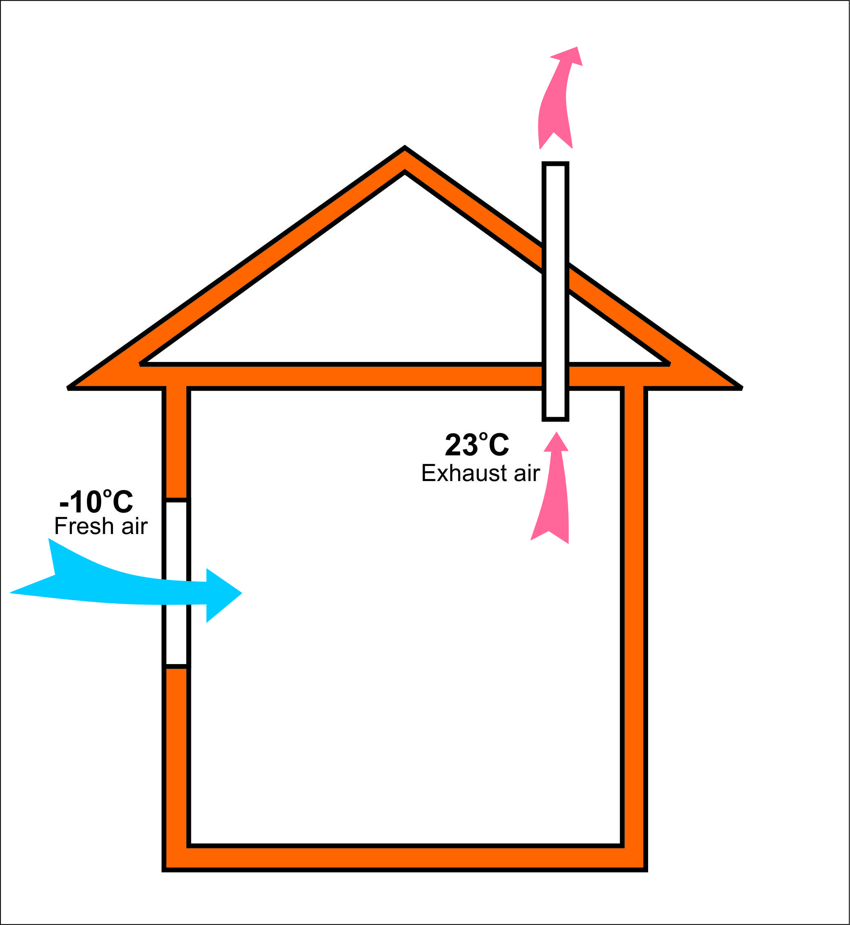 | 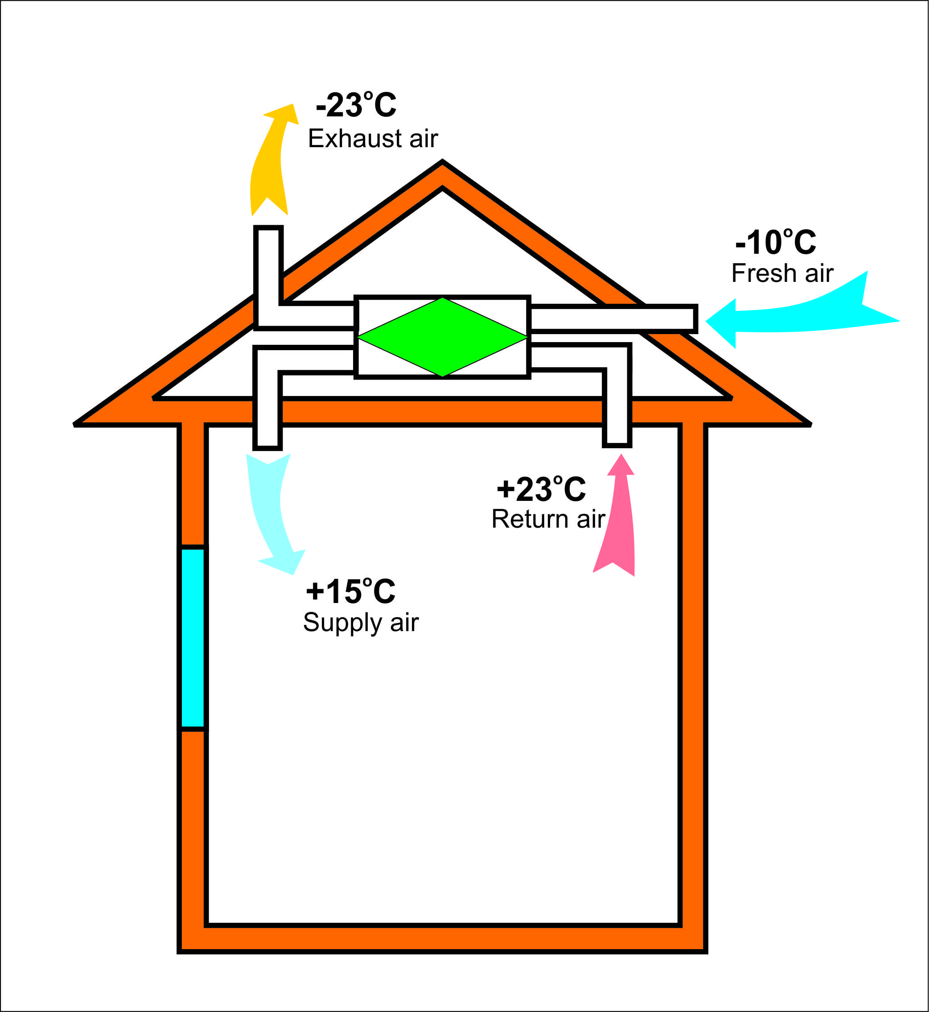
Type of ventilation system | Natural or natural and mechanical mixed system | Mechanical system
Regulation and control | Almost none | Well controlled
Filter | no | yes
Efficiency | none | More than 50 percent
Effect to Indoor air quality | bad | good

Table C: Installation of Highly Insulated Energy Efficient Curtain Wall System
Description | Common curtain wall system | Highly insulated curtain wall system
Picture | 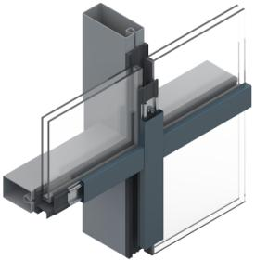 | 
U-value | >2.4 | <1.7, more thermal insulated
Air permeability | high | Much less
Thermal break between internal and external surface | less | good
Internal surface temperature in January | < 10ºC | >15ºC more warm and comfortable
Cost | 450000 MNT/m². | 650000 MNT/m2

Table D: Retrofit Low Efficiency Heat Only Boiler with High Efficiency Models
Description | Low efficiency, low quality boilers | High efficiency and good quality boilers
Picture | 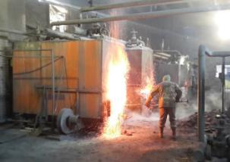
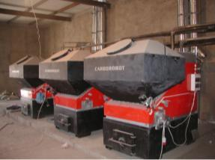Combustion efficiency | < 50% | >75%
Fuel | Brown coal | Brown coal
Regulation | Manual /less possibility/ | Full automatic w/wo ignition
Manufacturer | Local, China and some Russian | East European countries (Czech, Poland)
Working environment | Very bad, dusty and smoky | Relative clean
Cost USD/MW capacity | App. 100000-250000 USD | App. 300000 -600000 USD
Life time with water treatment | 5-10 years | 10-20 years

Table E: Installation of Wall Insulation
Description | Existing | Insulated
Picture | 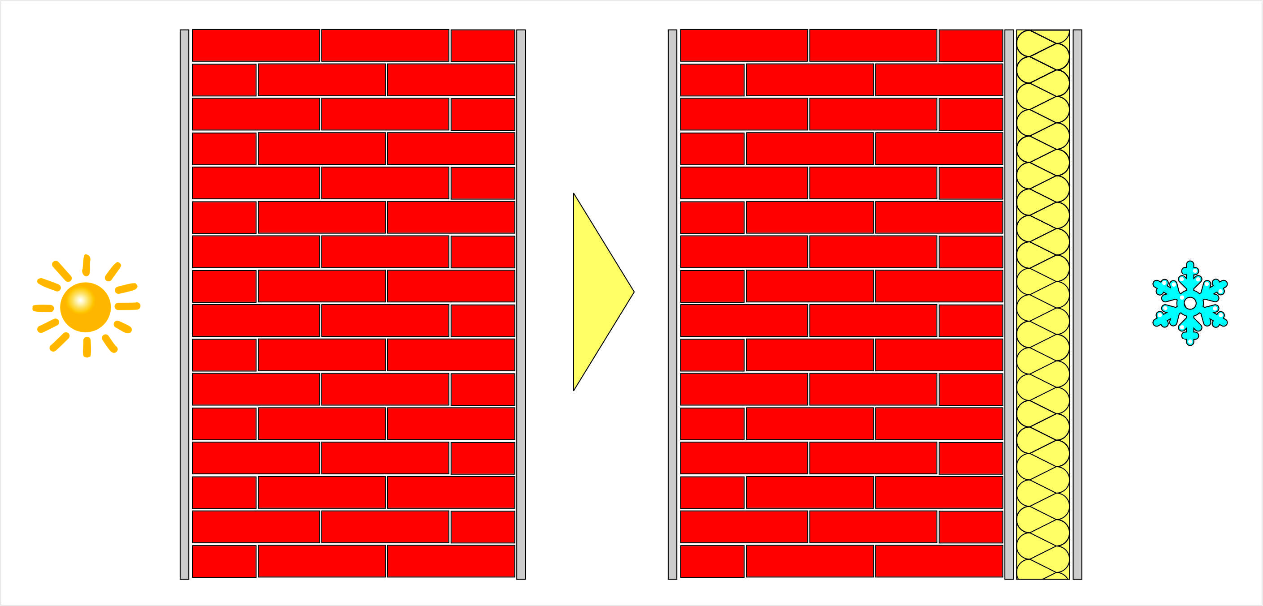
U- Value | 1.1 W/m²K | 0.27 W/m²K
Thickness of insulation | none | 15 cm
Insulation material | none | EPS or Mineral wool

Table F: Installation of Roof Insulation
Description | Existing | Insulated
Picture | 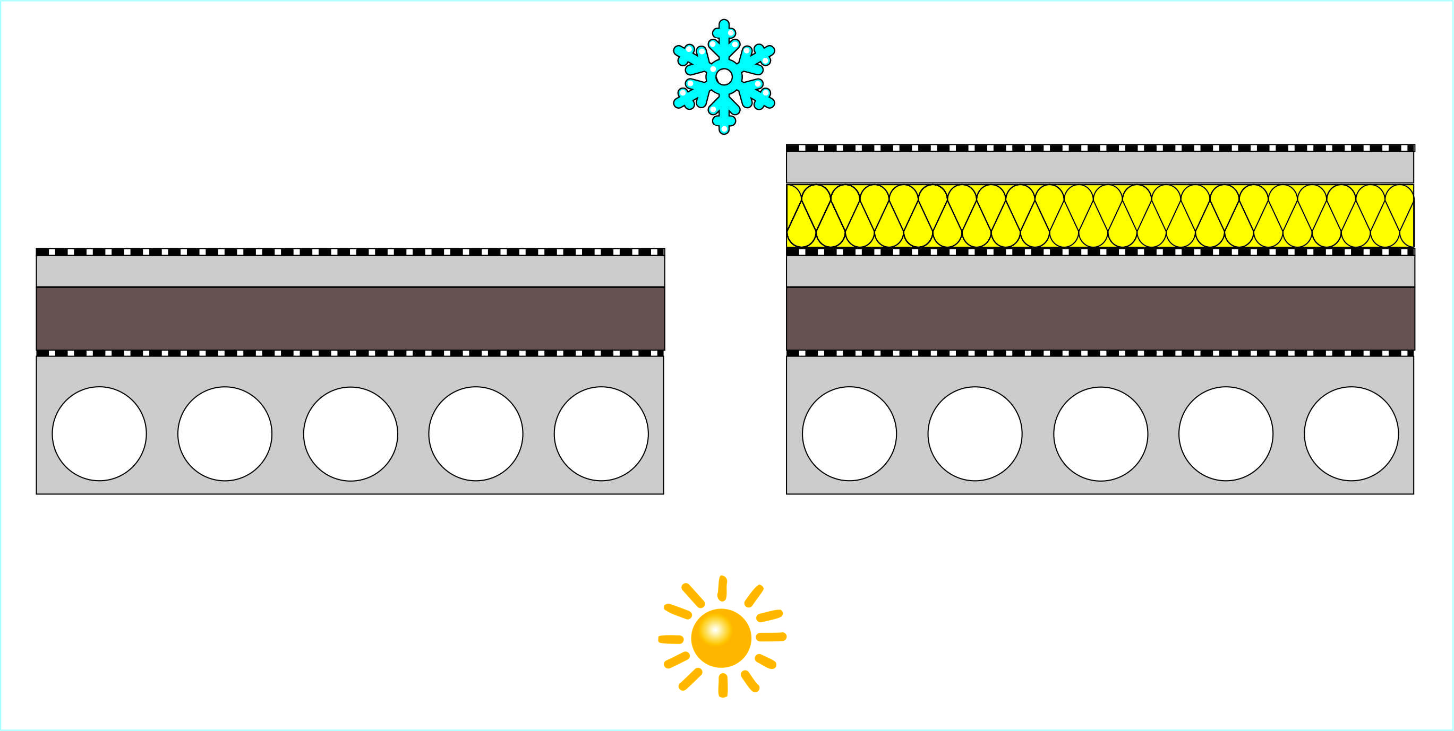
U- Value | 0.9 W/m²K | 0.18 W/m²K
Thickness of insulation | 5-15 cm | 25 cm
Insulation material | Coal ashes | EPS or Mineral wool

Table J: Solar PV system
Total capacity: | Grid Feed-in | Performance ratio
460 W | 623 kWh/Year | 81%


Annex II: Risk Analysis
OFFLINE RISK LOG
Project Title: Nationally Appropriate Mitigation Actions in the Construction Sector in Mongolia | Project ID: | Date:

# | Description | Date Identified | Type | Impact &  Probability | Countermeasures / Management Response | Owner | Submitted, updated by | Last Update | Status  (compared with previous evaluation)
1 | Policy measures are not in place to fully implement NAMAs |  | Policy | P = 1  I = 4 | The project will be implemented jointly with the MEGDT, the lead Ministry for climate change policy and responsible for development of the National Communication and other ministries MCUD for the construction sector and MOE for the energy sector. Furthermore, establishment with multi-stakeholders task forces will be ensured with representations from government entities, academia, and NGOS by decree of high-level government bodies, in order to support setting up of relevant regulatory mechanism. | Project manager | Submitted by Project Proponent, updated by Project Manager
2 | The construction sector may not support the idea of implementing CCM measures either on their own or through the NAMA process |  | Market | P= 2  I = 5 | The project will facilitate public private dialogues and engage the private sector early on to solicit their perspectives and needs for low carbon development. | Project manager | Submitted by Project Proponent, updated by Project Manager
3 | Weak capacities of stakeholders for project implementation and availability of reliable and sufficient amount of data |  | Institutional | P = 1  I = 4 | Systematic approach will be applied to address weakness in institutional capacities. This includes a) identifying stakeholders and conduct detailed assessment for capacity needs b) ensuring data availability by providing necessary measurement training tools and equipment | Project manager | Submitted by Project Proponent, updated by Project Manager
4 | Market demand for energy efficient building materials are low due to high initial costs compared to conventional building materials and technologies |  | Technical and financial | P = 3  I = 3 | The project will engage large property developers in investing in energy efficient projects to increase market demand. Innovative financing mechanism and policy intervention will help subsidize the cost of the EE buildings and increase the market demand. | Project manager | Submitted by Project Proponent, updated by Project Manager

Submitted by Project Manager ________________ Approved by UNDP Programme Analyst ______________

Annex III: Detailed CO₂ Calculations and Assumptions

The calculation of direct and indirect GHG emission reductions follows the methodology issued by GEF in “Calculating Greenhouse Gas Benefits of the Global Environment Facility Energy Efficiency Projects, Version 1.0, issued in March 2013, and the “GEF EE Tool v1.0” was used to calculate greenhouse gas benefits based primarily on the following methodology modules:
- Building Code Module
- Demonstration and Diffusion Module
- Financial Instrument Module

For the demonstration and diffusion module, a replication factor of 2 has been applied, based on the consideration that while the project can offer profitable EE implementation models, the replications in most cases will still be restricted to availability of funds and technical capacity of the project owners. As for the top down approach, a Level 2 Causality Factor of 40%, (GEF contribution is modest, and substantial) has been applied. Other key assumptions used in calculation of greenhouse gas benefits are summarized in the following table.
Table 17: Assumptions used in Calculation of Greenhouse Gas Benefits
General Parameter | Project Information
First Year of Project | 2017
Year of Project Close | 2020
Length of Analysis Period (Years After Project Close) | 10
Annual Construction Growth Rate (Commercial and High-Rise Residential Buildings) | 2.35% ^{(see note 1)}
Grid Heat T&D Loss Rate (%) | 10% ^{(see note 2)}
Grid Heat Emissions (tCO2/MWh) | 0.52 ^{(see note 3)}
Total Floor Area of Building Stock (m²) | 41,573,977 ^{(see note 4)}
Floor Area (m²) Subject to Code Built in Year 2017 | 1,027,446 ^{(see note 1)}
Cumulative Floor Area (m²) Subject to Code Built in Year 2017-2030 | 16,736,558 ^{(see note 1)}
Annual Reduction in Baseline Energy Consumption | 1% ^{(see note 5)}
Market Assumption | BAU Scenario | Project Scenario
Annual Electricity Consumption (kWh/m²) ^{(see note 6)} | 165 kWh/m² | 155 kWh/m² (Full BCNS Compliance)  124 kWh/m² (20% more efficient than BCNS)
Percent New Square Meters Built that fully Compliant with BCNS | 80% ^{(see note 7)} | 80% (2017)  100% (2020)
Percent New Square Meters Built that 20% more efficient than BCNS | 0% | 0% (2017)  5% (2020) ^{(see note 7)}
Note: 1. Estimation based on Mongolian statistics
2. Based on a default value in the GEF EE Tool V.1.0 which is equivalent to the World Bank data.
3. EF for heat grid based on calculation from the Building Energy Efficiency Center (BEEC)
4. Calculation by the Project Preparation Team from residential and commercial/public buildings connected to heat grid (data from utilities)
5. Assumption by the Project Preparation Team
6. For each scenario, the energy intensity values p are based on the Terminal Evaluation Report of BEEP, March 2014
7. Based on discussion with BEEC.

Based on the above assumptions, estimated emission reductions from the project are summarized in Table 18.

Table 18: Estimation of Emission Reduction from the Project
Description | Emission (tCO2)
Direct GHG Emission Reduction (EOP) | 10,709
Direct GHG Emission Reduction (Lifetime) | 64,219
Indirect Bottom-up Emission Reduction | 57,435
Indirect Top-down Emission Reduction | 438,926
Anticipated Direct Post Project Emission Reduction | 57,125

Estimation of the total market potential for emission savings is summarized in the table below.

Table 19: Estimation of the Total Market Potential for Emission Savings
Description | Energy Consumption (GWh) | Emission (tCO2)
Cumulative Baseline Scenario (2021-2030) | 18,922 | 10,823,218
Cumulative Full EE Potential Scenario (2021-2030) ^{(see note 1)} | 17,003 | 9,725,904
Total Market Potential (Cumulative Savings 2021-2030) | 1,919 | 1,097,314
Note: 1. All new buildings from 2020-2029 meet the BNCS requirements

The overall results and GHG benefits by component produced by the GEF EE Tool V.1.0 are presented on the following page.

Table 20: Overall Results
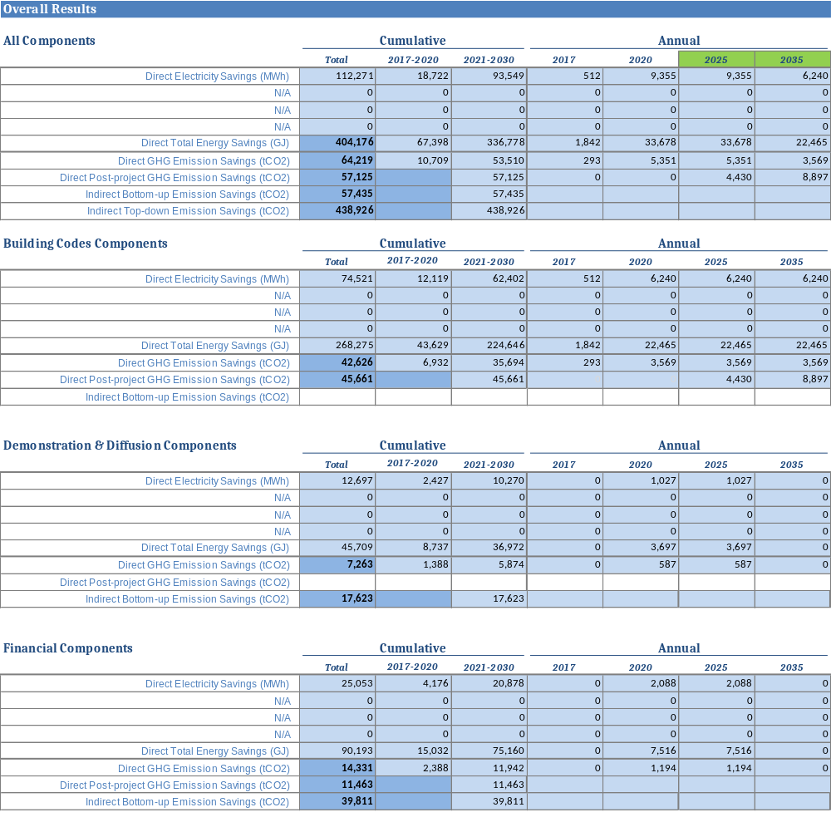
Table 21: Indirect Top-Down Impacts
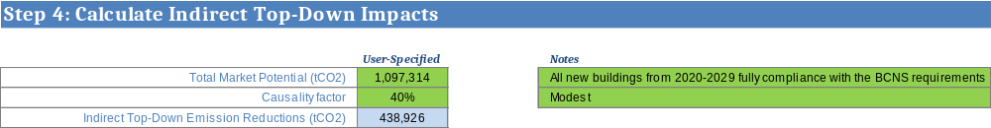

Annex IV: Co-Financing Letters (submitted as a separate file)

Annex V: Terms of Reference for Project Staff and Consultants

Key Project Management Post

National Project Manager (NPM):
Duties and Responsibilities: The incumbent will report to the National Project Director and will be responsible for implementation of the project, including mobilization of all project inputs, setup, implementation and maintenance of project’s internal control arrangements, supervision of project staff, consultants and oversight of sub-contractors. The PM will be the leader of the Project Team (PT) and shall liaise with the government, UNDP, and all stakeholders involved in the Project. S/he will be specifically responsible for (a) overall management of the project, (b) work closely with project stakeholders and ensure the project deliveries as per project document and work plan, (c) ensure technical coordination of the project and the work related to regulatory, institutional, financial and implementation aspects, (d) mobilize all project inputs in accordance with UNDP procedures and GEF principles, (e) finalize the ToR for the consultants and subcontractors and coordinate with Business Solution Center for recruitment, procurement and contracting, (f) supervise and coordinate the work of all project staff, consultants and sub-contractors, (g) ensure proper management of funds consistent with UNDP requirements, and budget planning and control, (h) prepare and ensure timely submission of monthly reports, quarterly consolidated financial reports, quarterly consolidated progress reports, annual, mid-term and terminal reports, and other reports as may be required by UNDP; (i) submit the progress reports and key issue report to the Project Steering Committee, (j) prepare quarterly and annual work plan, (k) arrange for audit of all project accounts for each fiscal year (l) undertake field visit to ensure quality of work, (m) undertake any activities that may be assigned by UNDP and Project Steering Committee, and (n) gender mainstream in project design, implementation and monitoring.

Qualifications and Experience: The incumbent should have a minimum Bachelor degree in Engineering with MBA/Master degree or Masters in energy/environment or other relevant academic discipline and profession qualifications with at least five (5) years professional experience at senior level. S/he should have extensive experience and technical ability to manage a large project and a good technical knowledge in the fields related to private sector development, climate change, energy efficiency, the construction and building materials sector and institutional development and/or regulatory aspects. Demonstrated understanding and experience of gender equality issues in energy efficiency construction and Familiarity with UNDP gender equality strategy will be an advantage. S/he must have effective interpersonal and negotiation skills proven through successful interactions with all levels of project stakeholder groups, including senior government officials, financial sectors, private entrepreneurs, technical groups and communities. S/he should have ability to effectively coordinate a complex, multi-stakeholder project and to lead, manage and motivate teams of international and local consultants to achieve results. Good capacities for strategic thinking, planning and management and excellent communication skills both in English and Mongolian are essential. Knowledge of UNDP project implementation procedures, including procurement, disbursements, reporting and monitoring will be an added advantage.

Admin Assistant (AA):
Duties and Responsibilities: The incumbent report to the National Project Manager and will be responsible to provide overall administration services of the Project in support of the Project Accountant and NPM such as processing payments. S/he will be responsible to provide information to UNDP Project web, RRMC reporting and administrative trouble shooting. S/he will also perform (a) word processing, drafting routine letters/messages/reports, mailing (b) arrange travel, itinerary preparation for project related travels, (c) assist to arrange workshops/seminar/training programs and mailing, (d) work at reception desk and make appointments and schedule meeting, (e) assist in work-plan and budgeting, (f) photocopying, binding and filing, (g) maintenance of all office equipment and keeping inventory/records of supplies and their usage and any other duties assigned by Project Manager or concerned officials (this would include providing administration to the management).

Qualifications and Experience: The incumbent should have at least a Bachelor degree in any discipline from a recognized university. S/he should have at least 3 years relevant working experience with foreign aided projects or international development or organizations. Computer proficiency in MS Office (Word, Excel and PowerPoint) and other common software is a prerequisite. Diploma in computer/secretarial science is desirable but not essential. Basic knowledge in procurement, petty cash handling, logistics supports, and filling systems is a basic requirement. Knowledge of UNDP project implementation procedures, including procurement, disbursements, and reporting and monitoring is preferable. Fluent both in written and spoken English and Mongolian is required.

Project Accountant (ACC):
Duties and Responsibilities: The incumbent will report to the National Project Manager and will be responsible to provide overall financial services of the project. S/he will be responsible to provide information to UNDP Project web, RRMC reporting and administrative trouble shooting. S/he will also prepare work-plan budgets and Project expenditure and any other duties assigned by Project Manager or concerned officials (this would include providing administration to the management).

Qualifications and Experience: The incumbent should have at least a Bachelor degree in finance and accounting or in relevant field. S/he should have at least 3 years relevant working experience with foreign aided projects or international development or organizations. Computer proficiency in MS Office (Word, Excel and PowerPoint) and other common software is a prerequisite. Diploma in computer/secretarial science is desirable but not essential. Basic knowledge in procurement, petty cash handling, and accounting systems is a basic requirement. Knowledge of UNDP project implementation procedures, including procurement, disbursements, and reporting and monitoring is preferable. Fluent both in written and spoken English and Mongolian is required.

National Consultants

Qualifications and Experience: All national consultants should have a minimum Bachelor degree in Engineering with relevant profession qualifications, and at least five (5) years of professional experience. Advanced degrees in energy/environment or other relevant academic discipline would be a plus. Good capacities for planning and management and excellent communication skills both in English and Mongolian are essential. Knowledge of UNDP project implementation procedures, including procurement, disbursements, and reporting and monitoring will be an added advantage.

Building Energy Efficiency Policy Expert:
Duties and Responsibilities: The incumbent will be responsible in:
- Reviewing policy/legislative/regulatory frameworks applied in the buildings sector in Mongolia;
- Working with MCUD to coordinate with MOE, MEDGT and relevant government agencies to prepare guidelines and handbooks to strengthen implementation of NAMA in Construction sector in Mongolia;
- Design and development of supporting mechanisms to strengthen enforcement of BCNS;
- Preparing technical and economic justifications, and roadmap and action plan to strengthen EE promotions in the building sector in Mongolia;
- Reviewing available information regarding building EE certification and labeling and green building schemes that are currently ongoing and/or were implemented in Mongolia and in other countries;
- Assessing appropriate options for MCUD to promote building EE certification and labeling and green building schemes for commercial and residential buildings;
- Preparing recommendations on the best options in consultation with stakeholders prior to conclusion and submission to MCUD.

Building Energy Efficiency/ NAMA Expert:
Duties and Responsibilities: The incumbent will be responsible in:
- Collection of data of energy consumption and GHG emission in construction sector
- Coordinating with utilities, MOE, MEGDT, MCUD and relevant government bodies for compilation of the most up-to-date data
- Coordinating with other international organizations that are implementing projects related to energy efficiency and GHG emission in buildings for mutual information sharing and triangulate of the data sources and reliability of references
- Conduct measurement of energy consumption if there is no existing data available or data is incomplete
- Correlation of collected data and support development of reference baseline of energy consumption and GHG inventory system in Construction sector
- Support development of Emission Factor of Mongolia in coordination with MEDGT
- Compile information on EE building materials (insulation and lighting) of difference type, brands, technical specifications, quality, price and availability in Mongolia for development of Marginal Cost Curve.
- Drafting of Implementation Agreement (IA) for data collection and NAMA implementation in coordination with key stakeholders e.g. MCUD, MOE, MEGDT, utilities

Building Measuring, Reporting and Verification (MRV) Expert:
Duties and Responsibilities: The incumbent will be responsible in:
- Reviewing any Energy Audit and Measurement and Verification (M&V) protocol previously developed by MCUD or other agencies in Mongolia well as common approaches being adopted by Energy Auditors and EE consulting firms in Mongolia;
- Reviewing the latest edition of International Performance for Measurement and Verification Protocol (IPMVP) against the Mongolia practices;
- Summarize findings and develop Building Measuring, Reporting and Verification (MRV) guideline.
- Supervise the implementation of MRV in pilot projects

Energy Efficiency Financing Expert:
Duties and Responsibilities: The incumbent will be responsible in:
- Analysis and assessment of existing financial schemes for mortgage loan in Mongolia from the perspective of financial institutions and building stakeholders;
- Providing recommendations on new and innovative financial schemes for EE investment in commercial buildings;
- Developing the most appropriate scheme (or a combination of schemes) for enhancement of EE investments in commercial and high-rise residential buildings together with selection criteria for the financing schemes and the selection of eligible borrowers;
- Analysis of cost and benefit ratios of proposed fiscal policies and preparing a report detailing the terms and conditions of the schemes, including assessment of source of finance;
- Engaging relevant stakeholders as a working group to assess how much financing will be extended to EE building projects through the new schemes, and organizing a series of round table discussion, meetings and workshop with commercial banks/financial institutions to provide technical advice to banking/financial institutions to get their interest in providing financing based on the new schemes to prospective EE building projects;
- Conducting a series of formal and informal meetings with XacBank’s management level, and obtain necessary approvals;

NAMA Capacity Building Expert:
Duties and Responsibilities: The incumbent will be responsible in:
- Conducting capacity building/training needs assessment of MCUD, MOE, MEGDT and the different stakeholders in the buildings sector;
- Conducting a scoping study to develop an inventory of training institutions, resource speakers and experts that will be involved in the conduct of the training courses;
- Designing relevant training programs addressing the identified needs of the target institutions and participants
  - Training for effective measurement and data collection (1 module)
  - Training for GHG inventory (1 module)
  - Training on implementing of NAMA and financing (3 modules)
  - Training for MRV implementation (1 module)
- Advising the local situation concerning the conduct of training courses, and assist the International Consultant;
- Designing a course syllabus for each training course to be prepared specifying the actual target participants, the actual resource speaker/s, and the teaching strategies to be adopted for each course, training duration, logistics needed, etc.;
- Proposing a suitable framework for the implementation of the follow-up program and training needs;
- Conducting training courses on EE technologies and practices for personnel attached to demonstration buildings and other buildings which express their willingness and capacity in replicating successes from the demonstration projects;
- Conduct reports of results of capacity building incorporating pre and post assessment of trainee’s knowledge, understanding and ability to implement the knowledge learnt in actual practices for each module.

NAMA and MRV Implementation Expert:
Duties and Responsibilities: The incumbent will be responsible in:
- Providing technical advisory services in the Detailed Feasibility Studies of Selected Demonstration Sites;
- Providing technical advice on meeting specific Demonstration Project Implementation Requirements;
- Establishing baseline data for the Demonstration Project Sites;
- Supervise and closely monitor the implementation of MRV in the Demonstration pilot sites;
- Providing assistance in identification of appropriate financing of the operation and maintenance of each demonstration site;
- Assisting preparation of technical specifications and procurements;
- Acting as the focal points for demonstration project implementation;
- Working with project hosts during procurements, installations and commissioning;
- Working with demonstration hosts to regularly monitor implementation results using the MRV guideline

International Consultants

Qualifications and Experience: All international consultants should have a minimum Bachelor degree in Engineering with relevant profession qualifications, and at least seven (7) years of professional experience. Advanced degrees in energy/environment or other relevant academic discipline would be a plus. Good capacities for planning and management and excellent communication skills in English are essential. Knowledge of UNDP project implementation procedures, including procurement, disbursements, and reporting and monitoring will be an added advantage.

Building Energy Efficiency Policy Expert:
Duties and Responsibilities: The incumbent will be responsible in:
- Reviewing policy/legislative/regulatory frameworks applied in the buildings sector in Mongolia and other countries (developed and developing), particularly incentives program;
- Providing recommendations on strengthening existing measures or introducing new measures (certification, labeling, benchmarking, information disclosure, etc.) with appropriate scope and action plans in order to promote NAMA of EE in the commercial building sector in a long term;
- Supporting national consultant in analysis of cost and benefit ratios of proposed fiscal policies;
- Proposing recommendations towards reaching agreements on mobilizing local and international financial institutions and local resources to support NAMA project investments in the building sector;

Building Energy Efficiency/ NAMA Expert:
Duties and Responsibilities: The incumbent will be responsible in:
- Correlation of collected data, triangulate data from difference sources, categorize, classify and analysis of data;
- Development of NAMA inventory in construction sector in Mongolia;
- Development of reference baseline of energy consumption and GHG inventory system in Construction sector;
- Development of Emission Factor of Mongolia;
- Prioritize the most cost effective energy efficiency measures using Marginal Cost Curve for technologies in building insulation and lighting.

Building Measuring, Reporting and Verification (MRV) Expert:
Duties and Responsibilities: The incumbent will be responsible in:
- Reviewing any Energy Audit and Measurement and Verification (M&V) protocol previously developed by MCUD or other agencies in Mongolia as well as common approaches being adopted by Energy Auditors and EE consulting firms in Mongolia;
- Reviewing the latest edition of International Performance for Measurement and Verification Protocol (IPMVP) against the Mongolia practices;
- Summarize findings and develop Building Measuring, Reporting and Verification (MRV) guideline;
- Provide technical advices for the implementation of MRV in pilot projects.

Energy Efficiency Financing Expert:
Duties and Responsibilities: The incumbent will be responsible in:
- Support the analysis and assessment of existing financial schemes for mortgage loan in Mongolia;
- Reviewing the financial systems (government and private) in other countries (developed and developing) for financing building construction projects, as well as those that are lending to building EE projects;
- Providing recommendations on new and innovative financial schemes for EE investment in construction sector;
- Support development of the most appropriate scheme (or a combination of schemes) for enhancement of EE investments in commercial and residential buildings together with selection criteria for the financing schemes and the selection of eligible borrowers;
- Support XacBank in analyzing its mortgage loan portfolio and provide recommendation for the bank to improve its loan performance.

NAMA Capacity Building Expert:
Duties and Responsibilities: The incumbent will be responsible in:
- Supporting national consultants in capacity building/training needs assessment of the different stakeholders in the buildings sector;
- Designing relevant training programs addressing the identified needs of the target institutions and participants;
- Supporting national consultants in designing a course syllabus for each training course to be prepared specifying the actual target participants and provide recommendation on qualified trainer/s for the following courses
  - Training for effective measurement and data collection (1 module)
  - Training for GHG inventory (1 module)
  - Training on implementing of NAMA and financing (3 modules)
  - Training for MRV implementation (1 module)

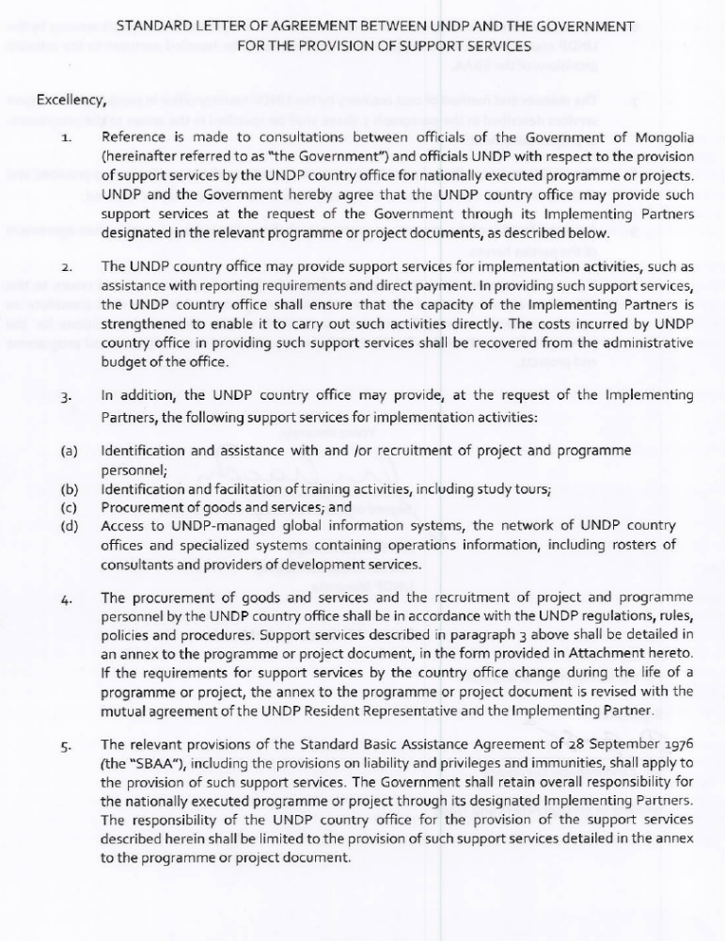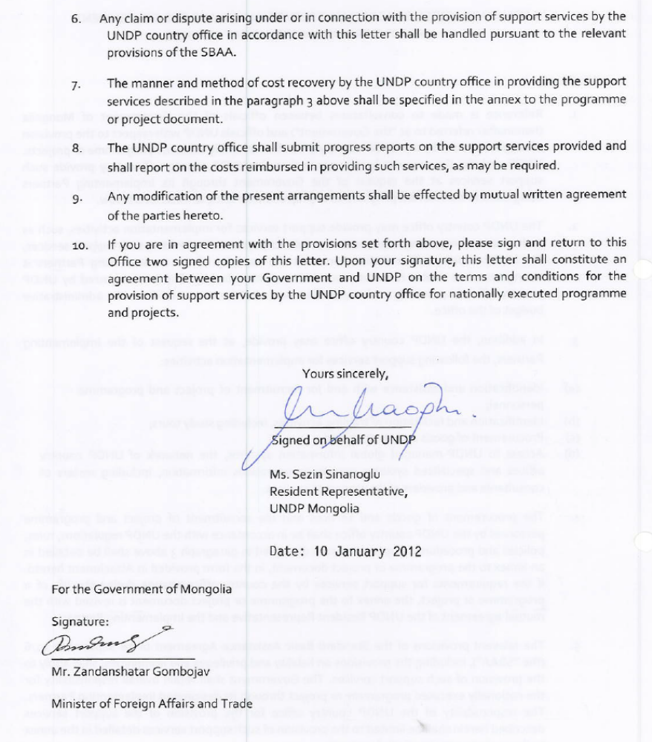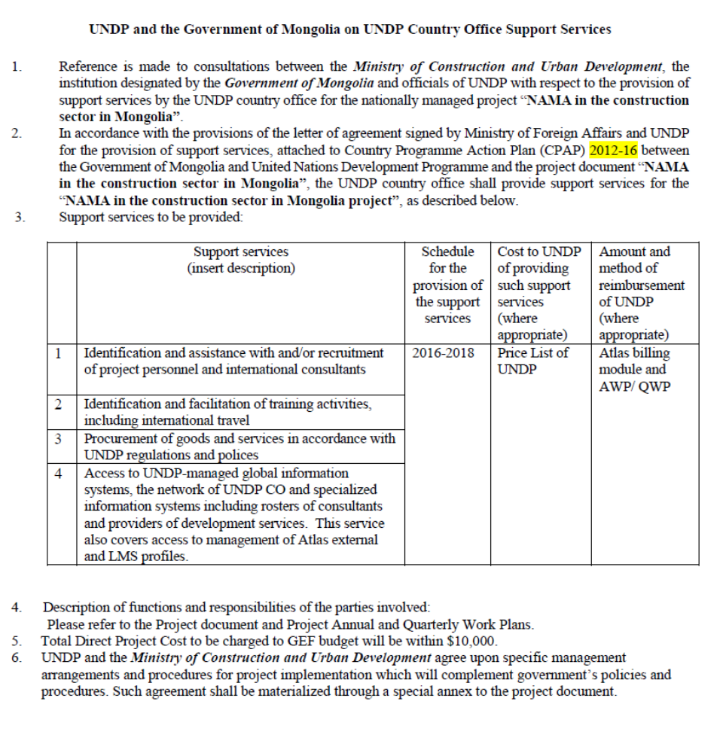

https://www.imf.org/external/pubs/ft/wp/2015/wp1590.pdf
http://www.adb.org/countries/mongolia/economy
Thermo-Technical Rehabilitation of Pre-cast-Panel Buildings in Ulaanbaatar, TTR Feasibility Study Phase 1 Report, GITEC, 2011
Estimations by the Project Preparation Team with reference data from Table 2 and Table 3
The cubic volume of public/commercial building is converted to floor area by assuming that the floor-to-ceiling height is 2.7 meters.
See http://www.adb.org/news/mongolia-s-economy-grow-less-2015-weighed-down-macroeconomic-imbalances
GITEC/IWO, KFW, June 2011: Thermo-Technical Rehabilitation of Precast-Panel Building in Ulaanbatar, TTR-Feasibility Phase 1 Report.
Strategies for Development of Green Energy Systems in Mongolia (2013-2035), Global Green Growth Institute, 2015
Source: Ministry of Energy
INDC and SNC
Energy Modeling by the Global Green Growth Institute
INDC
Triple glazing is widely used in cold climate countries like Sweden and Norway, and the ultra-low energy PassivHaus standard requires triple glazed windows with a U value of no more than 0.8. Window with average U-values as low as 0.5W/m²K are available in Europe and North America, see http://www.munsterjoinery.ie/productdetails9
Based on the precast panel building area from the TTR Feasibility Study Phase 1 Report and the total floor area of heat energy grid connected buildings.
Ibid ³
BEEP closing date is 31st December 2013.
The IA in this project refers to a set of institutional, legal and procedural arrangements. It could be in the form of formal arrangements such as regulations, directives, laws, decrees, or MOUs.
Technology Needs Assessment , Volume 2 – Climate Change Mitigation in Mongolia, MEGDT, 2013, funded by UNEP/GEF
The Improving Energy Efficiency in the Residential Buildings Sector of Turkmenistan project estimated the abatement cost at USD15.8/tCO2e. India: IND Energy Efficiency Improvements in Commercial Buildings, the abatement cost estimated at USD5.7/t CO2e; Malaysia: Buildings Sector Energy Efficiency Project (BSEEP), the abatement cost estimated at USD4.3/t CO2e; Promoting Energy Efficiency in Commercial Buildings in Thailand (PEECB), the abatement cost estimated at USD37.3/t CO2e;
Cumulative CO2 emission reduction and energy savings in the baseline scenario is a result of 1% annual reduction in baseline energy consumption due to adoption of EE technologies and EE investments in the construction sector in Mongolia in absence of GEF intervention. The calculation is based on the guideline and Excel spreadsheet tool published by GEF in March 2013.
Ibid 20
Cumulative CO2 emission reduction and energy savings in the NAMA in Construction project scenario is a result of better compliance with the revised building code (from 80% without GEF intervention to 100% at the end of project), together with direct emission reductions from demonstration projects and their replications, and investments stimulated by the financial tools.
Ibid 22
People employed by demo projects, financial institutions, and technical personnel involved in EE design and implementation in the construction sector
No energy consumption and GHG inventory system/framework for the construction sector adopted and used by MCUD

